Algebra Collated Past Papers - Algebraic Manipulation

2023 Question 1a.
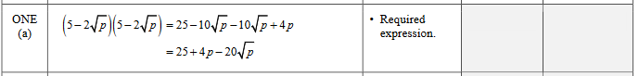

2023 Question 2a.
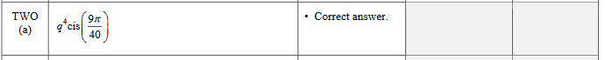

2023 Question 2b.
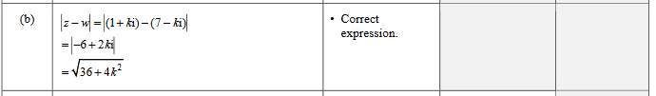

2022 Question 1a.
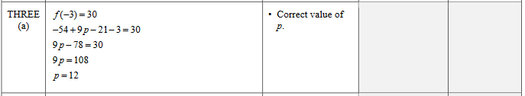

2022 Question 1b.
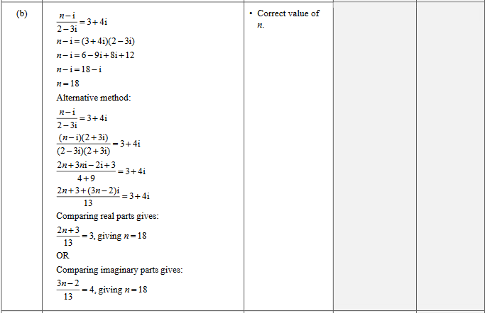

2022 Question 2b.
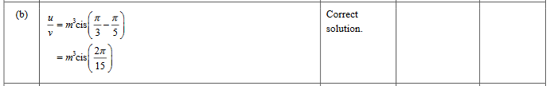

2022 Question 3e.
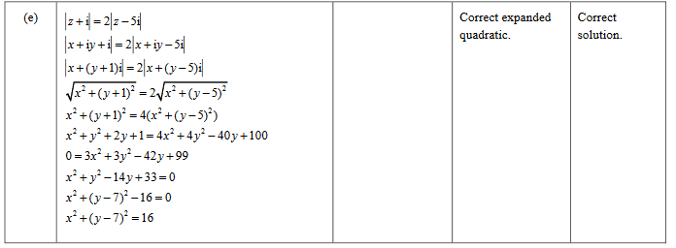

2021 Question 1a.

2021 Question 2a.
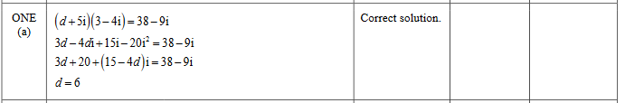

2021 Question 3b.
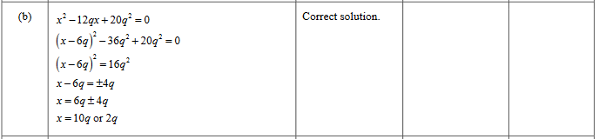

2020 Question 1a.
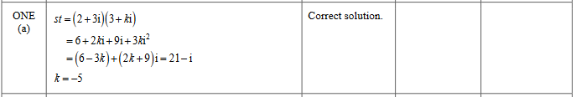

2020 Question 1d.
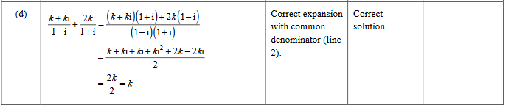

2020 Question 3a.

2019 Question 1e.
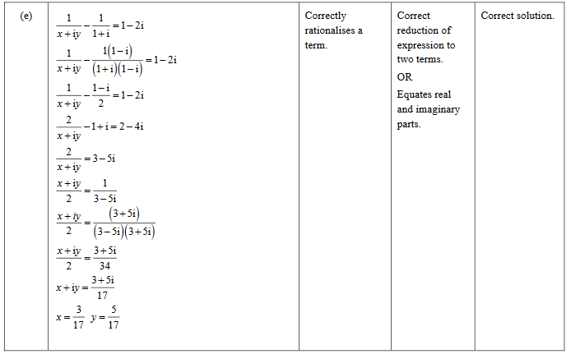

2019 Question 2a.
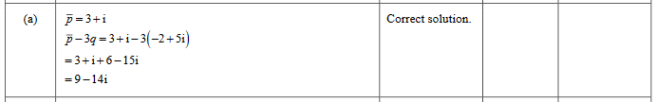

2019 Question 2b.
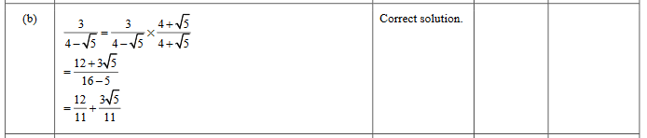

2019 Question 2d.
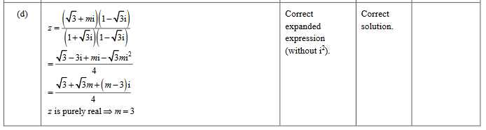

2019 Question 3a.
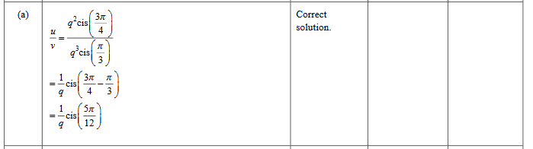

2019 Question 3b.

2018 Question 2b.

2018 Question 3a.
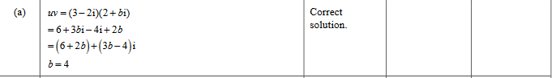

2017 Question 1a.

2017 Question 1b.
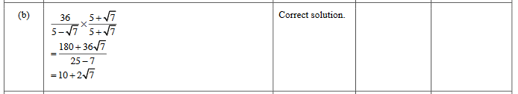

2017 Question 2b.

2017 Question 2e.
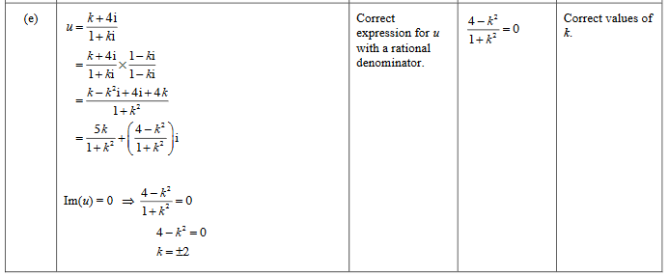

2017 Question 3a.

2016 Question 1d.
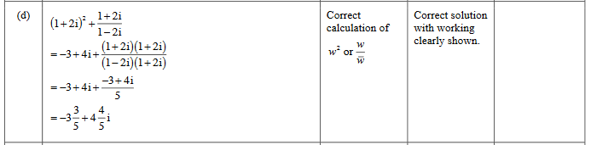

2016 Question 2b.
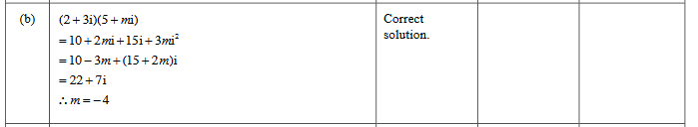

2016 Question 3a.

2016 Question 3b.

2015 Question 1c.
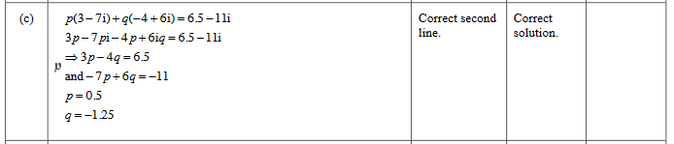

2015 Question 2b.
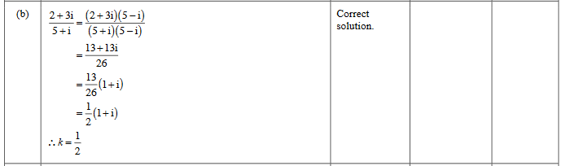

2015 Question 2c.
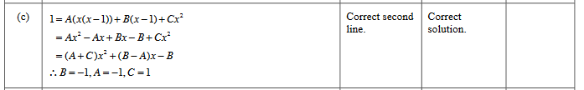

2015 Question 2d.
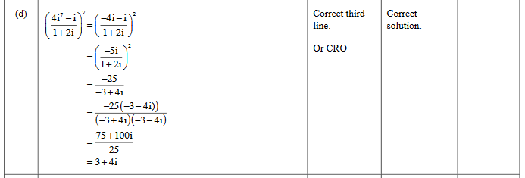

2014 Question 1b.
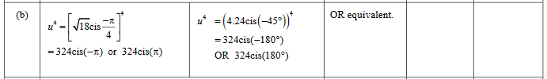

2014 Question 2b.
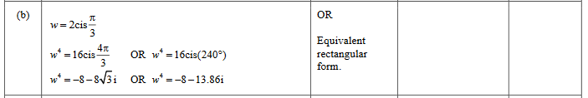

2014 Question 3a.

2014 Question 3d.
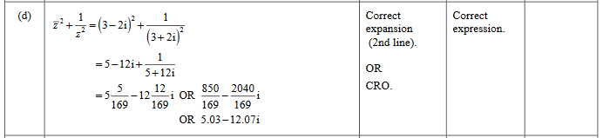

2013 Question 1a.

2013 Question 2b.

2013 Question 3b.
