Algebra Collated Past Papers - Algebraic Manipulation

2023 Question 1e.
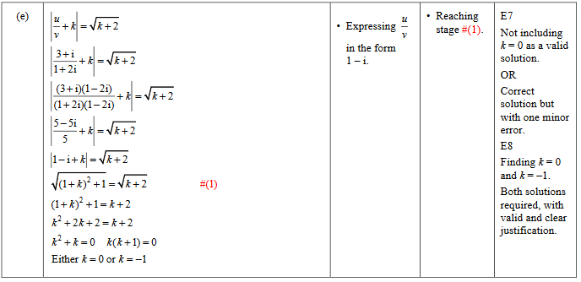

2023 Question 2c.
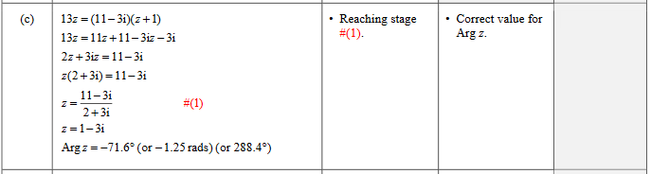

2023 Question 2e.
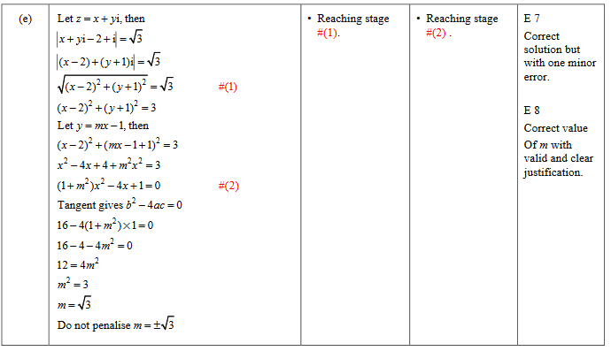

2022 Question 1c.
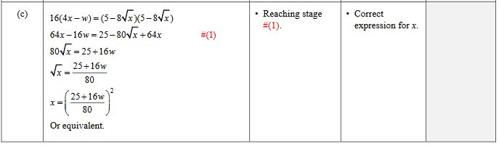

2022 Question 2d.
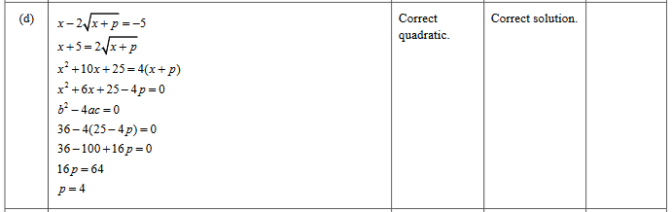

2022 Question 2e.
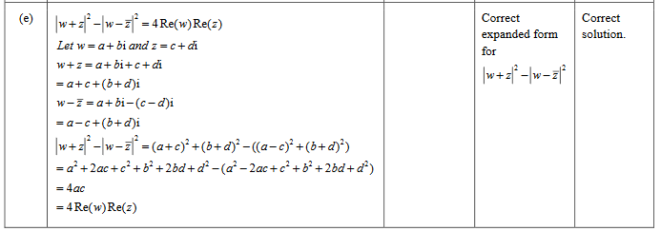

2021 Question 1d.
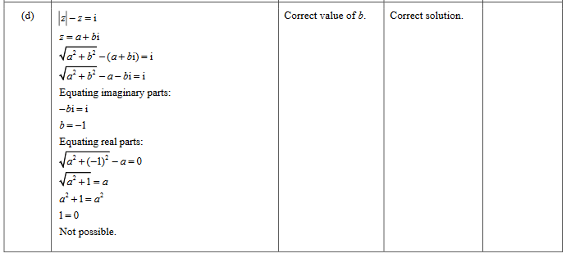

2021 Question 2e.
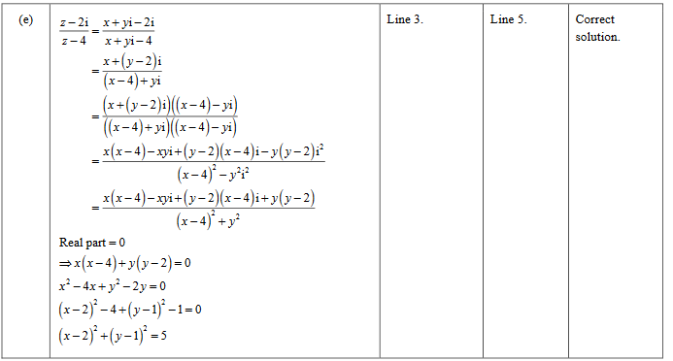

2021 Question 3a.
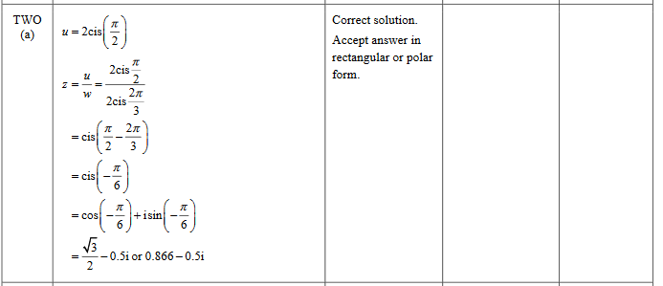

2020 Question 2b.
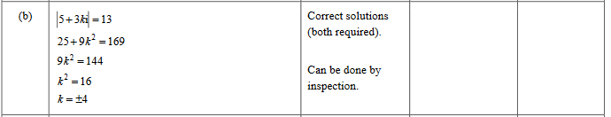

2020 Question 2d.
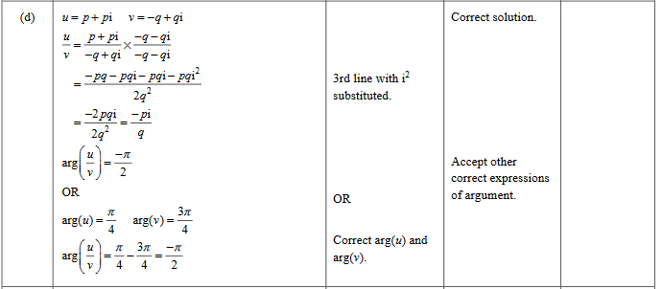

2020 Question 2e.
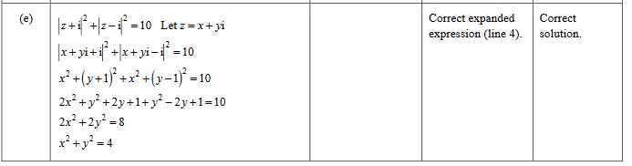

2019 Question 1c.
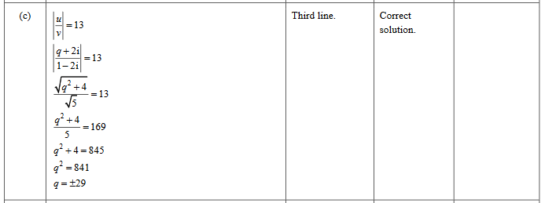

2019 Question 3d.
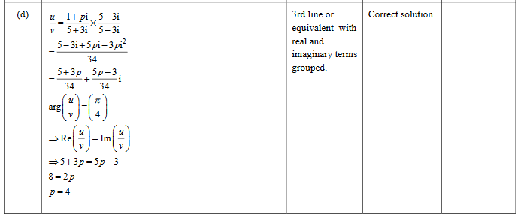

2018 Question 2d.
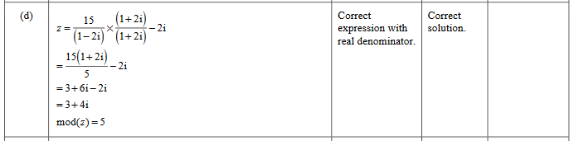

2018 Question 2e.
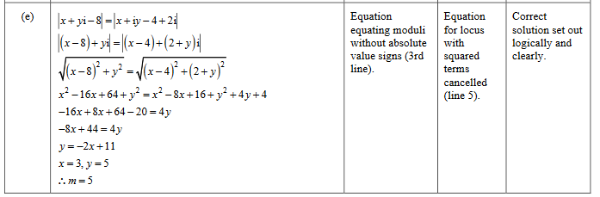

2018 Question 3d.
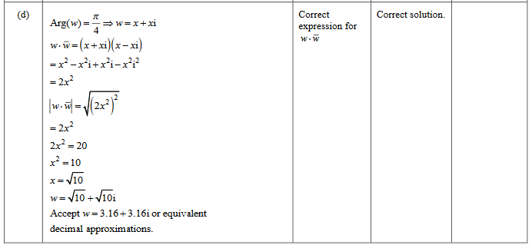

2017 Question 1e.
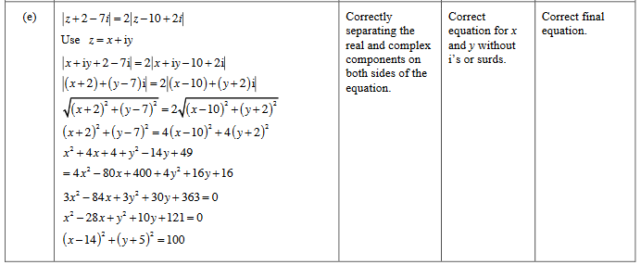

2017 Question 2c.
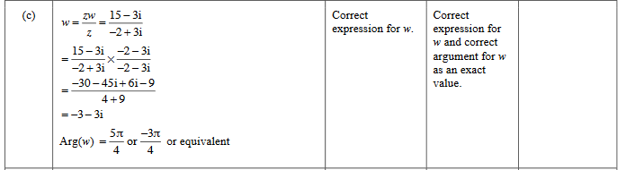

2016 Question 1e.
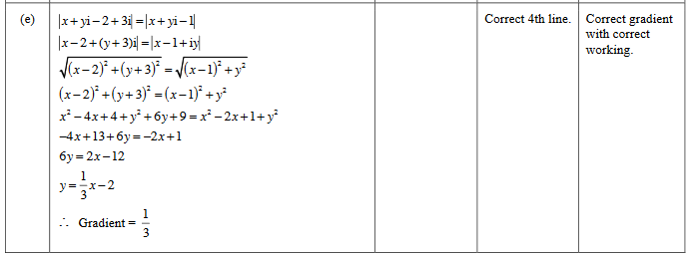

2015 Question 2e.
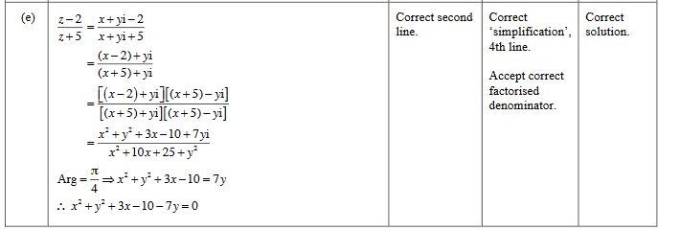

2015 Question 3a.
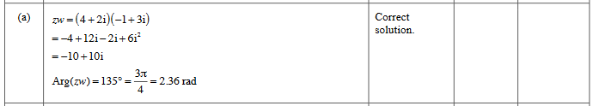

2014 Question 1e.
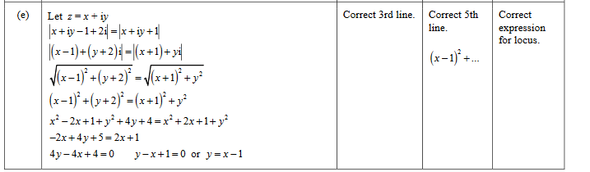

2014 Question 2e.
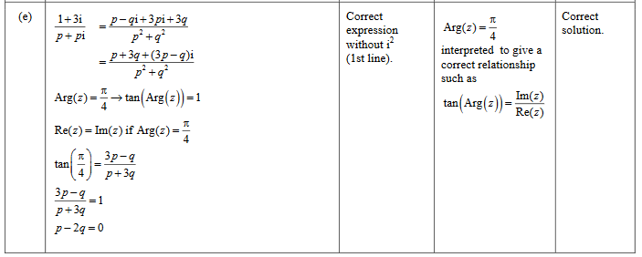

2013 Question 1d.
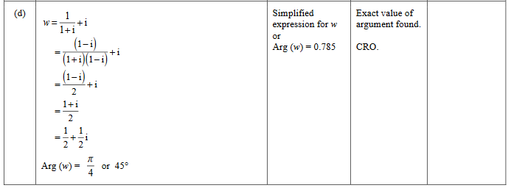

2013 Question 1e.
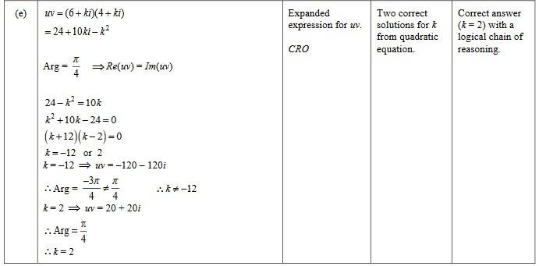

2013 Question 2e.
