Algebra Collated Past Papers - Algebraic Manipulation

2023 Question 1a.
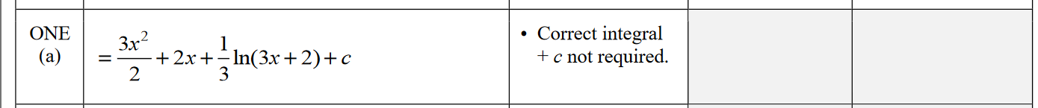

2023 Question 2a.

2023 Question 2c.
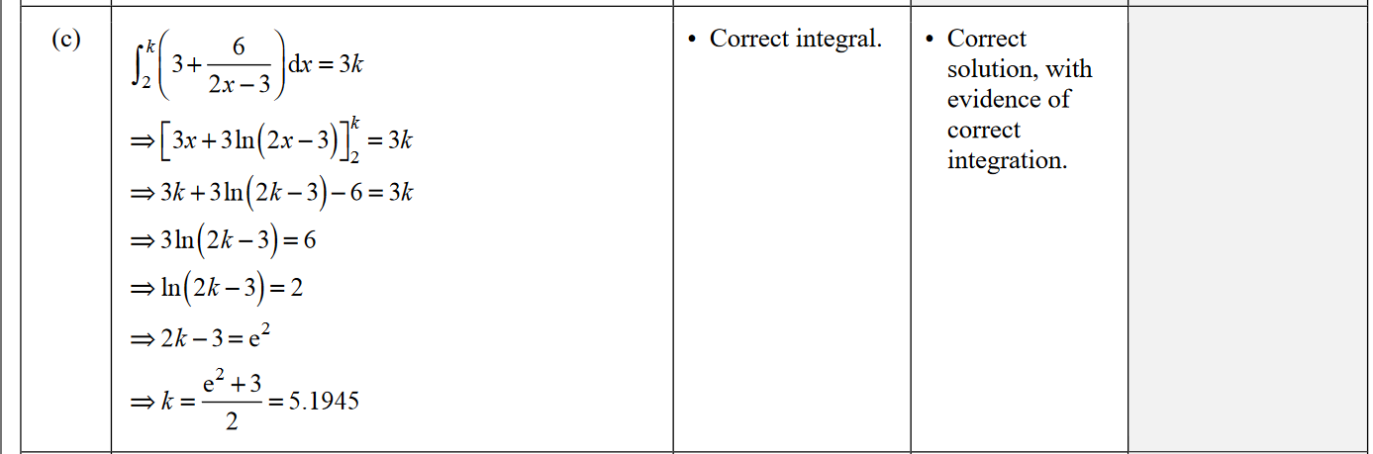

2023 Question 2d.
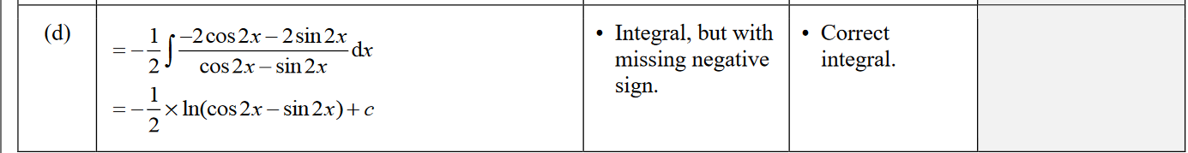

2023 Question 3b.
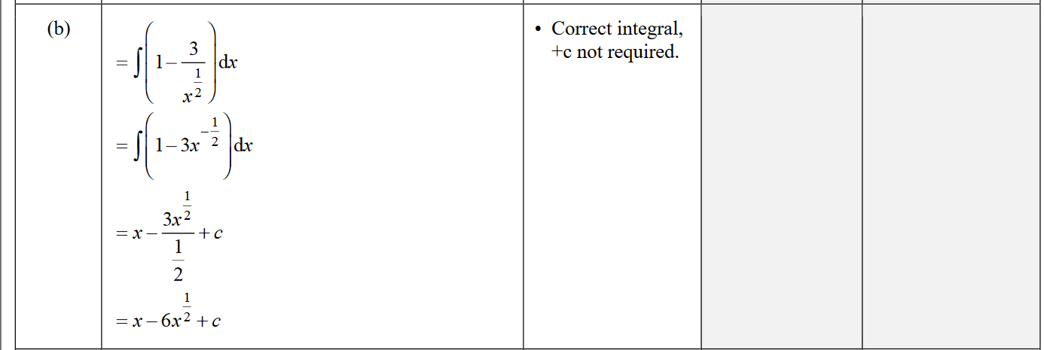

2022 Question 1a.

2022 Question 1c.
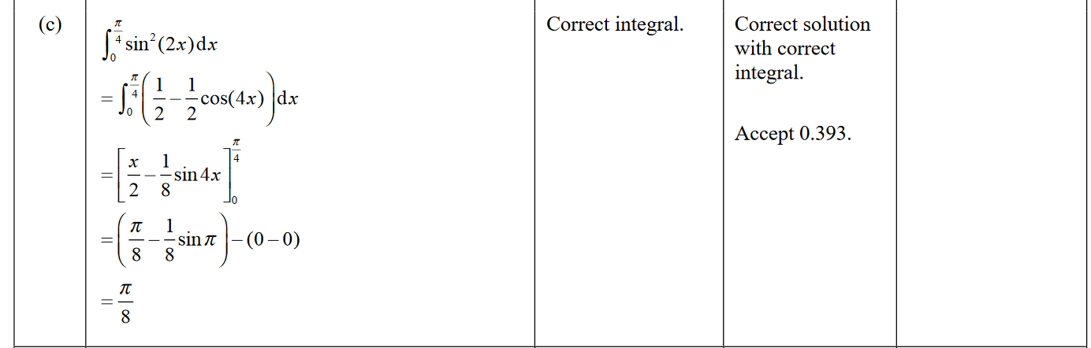

2022 Question 2a.

2022 Question 2b.
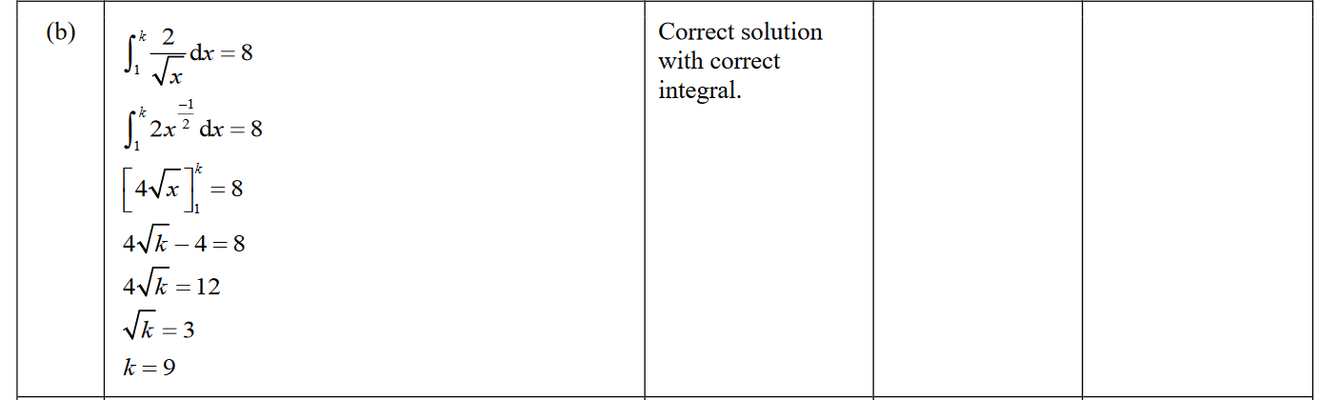

2022 Question 3a.

2022 Question 3c.
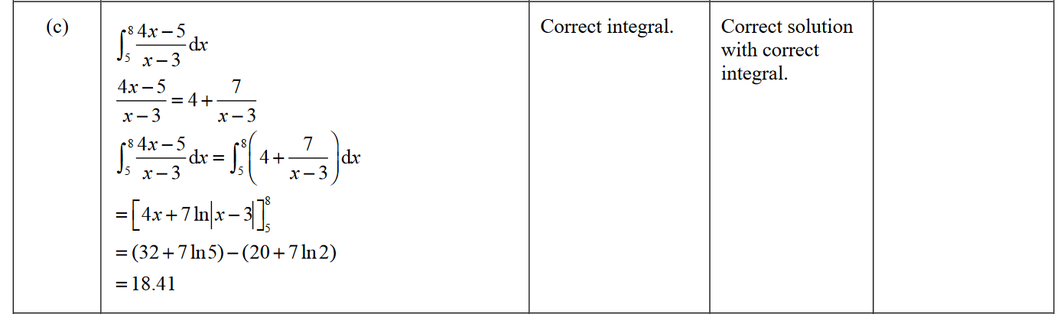

2021 Question 1a.

2021 Question 2a.

2021 Question 2b.

2021 Question 2c.
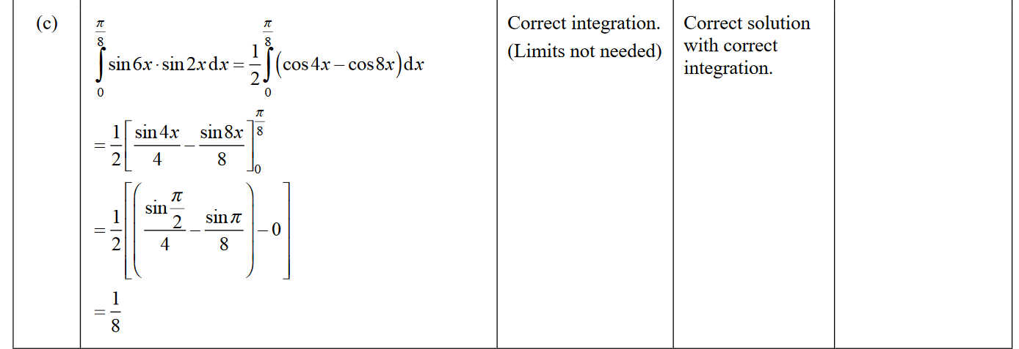

2021 Question 3a.
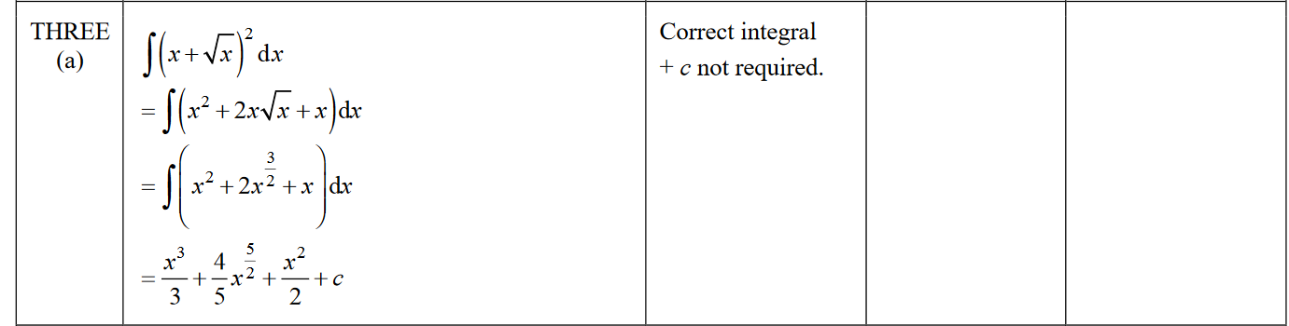

2020 Question 1a.

2020 Question 1c.
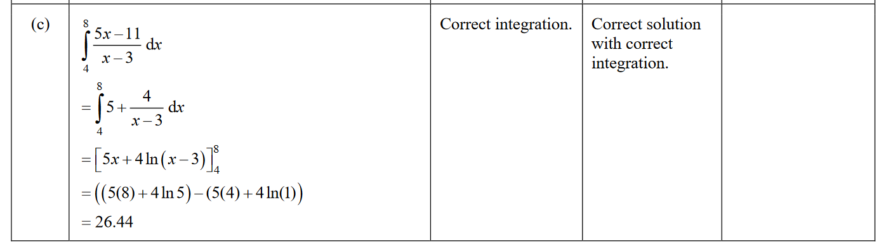

2020 Question 2a.

2020 Question 2c.
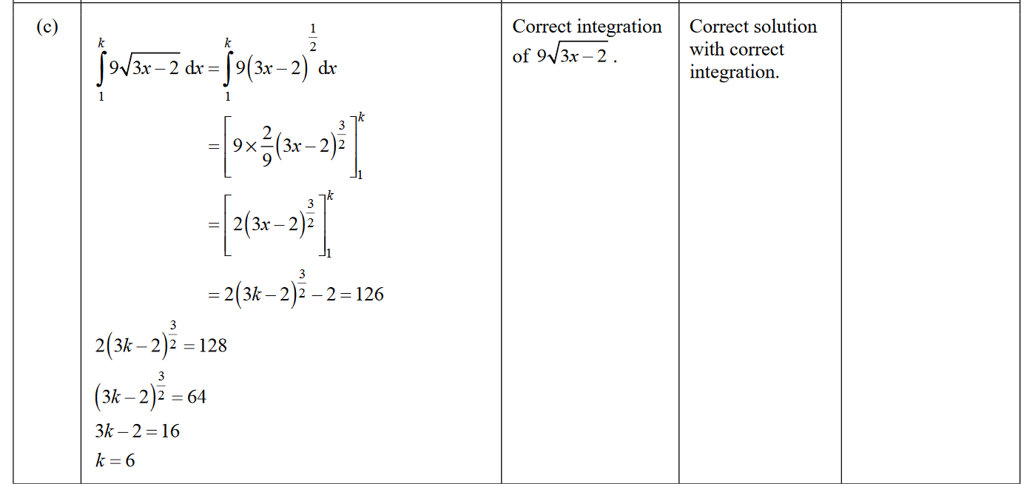

2020 Question 3a.

2019 Question 1a.

2019 Question 1c.
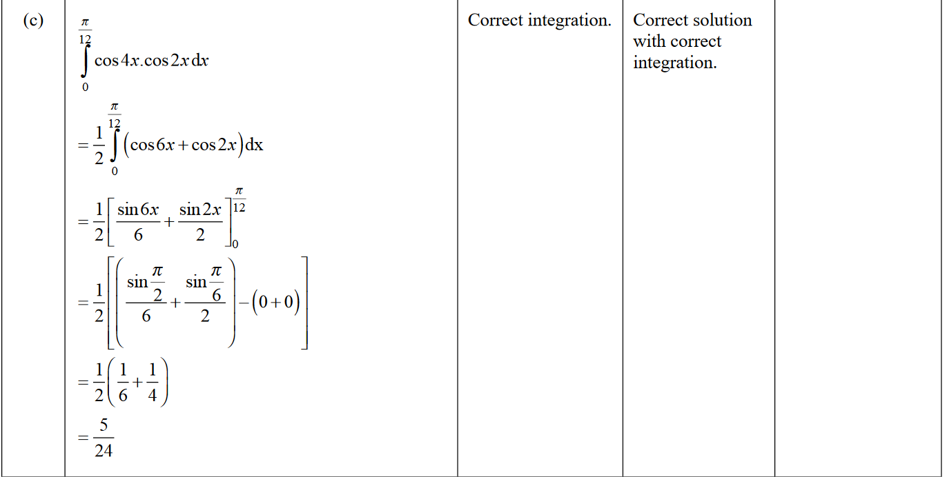

2019 Question 2a.

2019 Question 2c.
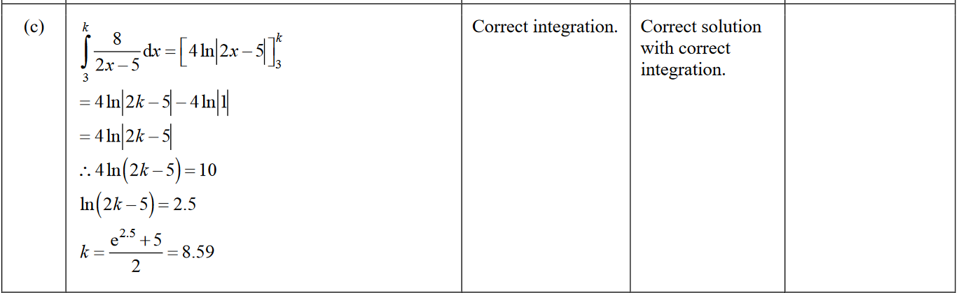

2019 Question 3a.
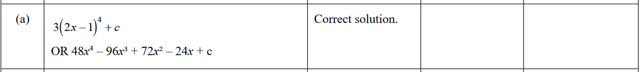

2019 Question 3c.
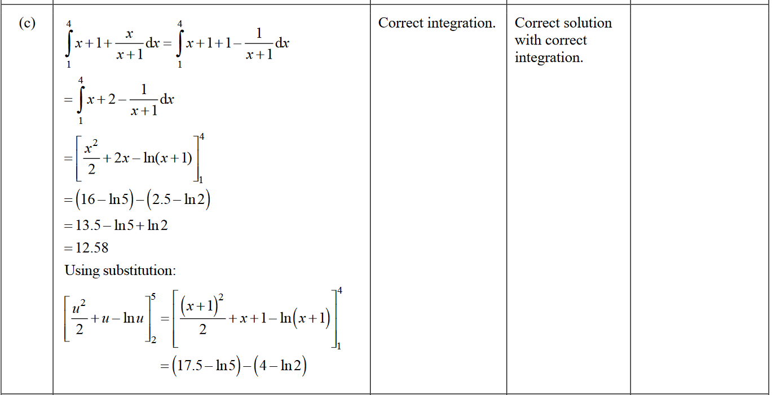

2018 Question 1a.

2018 Question 1c.
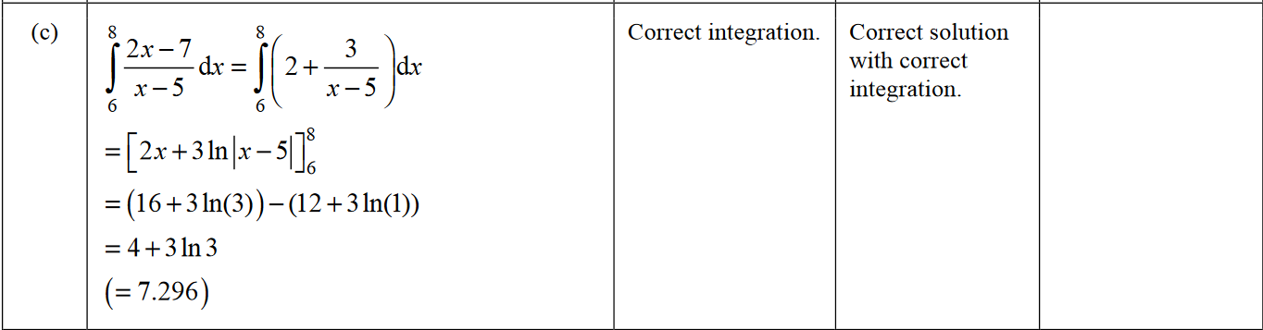

2018 Question 2a.

2018 Question 2b.
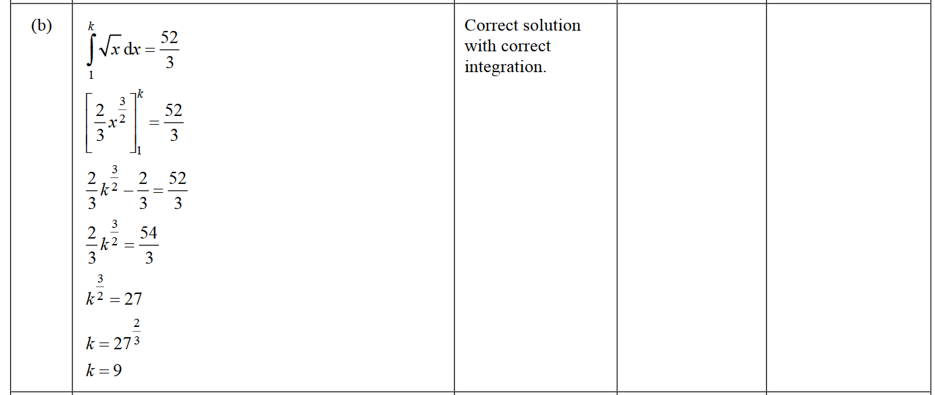

2018 Question 3a.
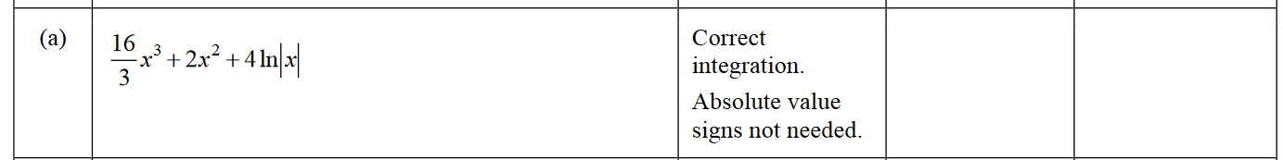

2018 Question 3c.
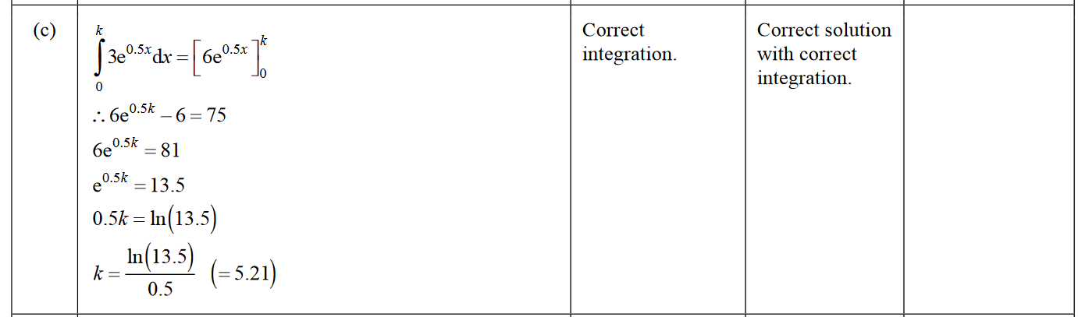

2017 Question 1a.

2017 Question 1d.
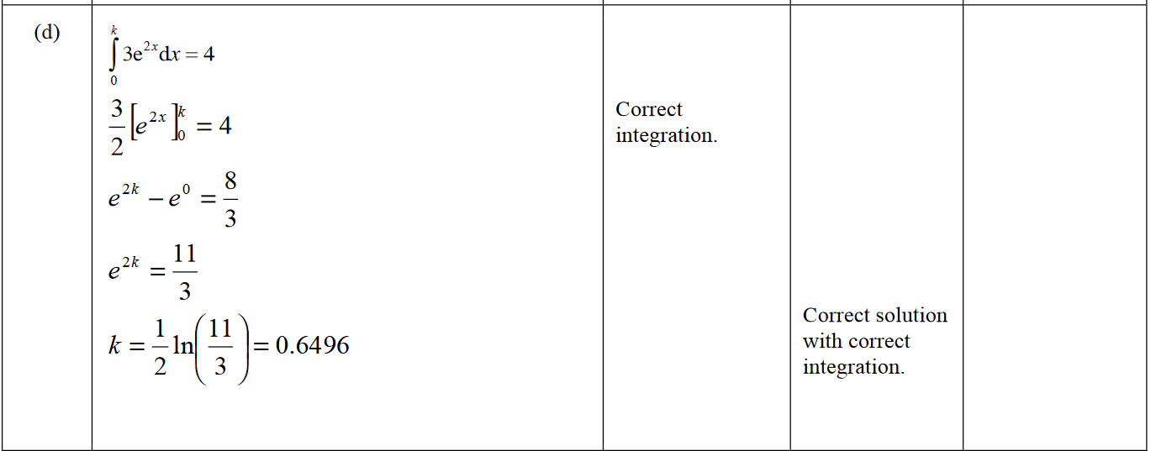

2017 Question 2a.

2017 Question 2b.
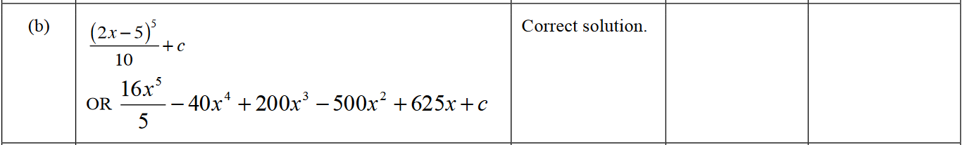

2017 Question 3a.

2016 Question 1a.
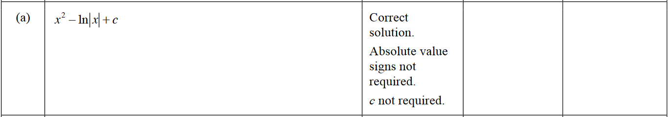

2016 Question 1b.
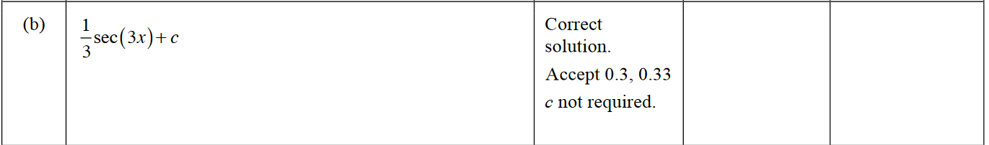

2016 Question 2a.

2016 Question 2d.
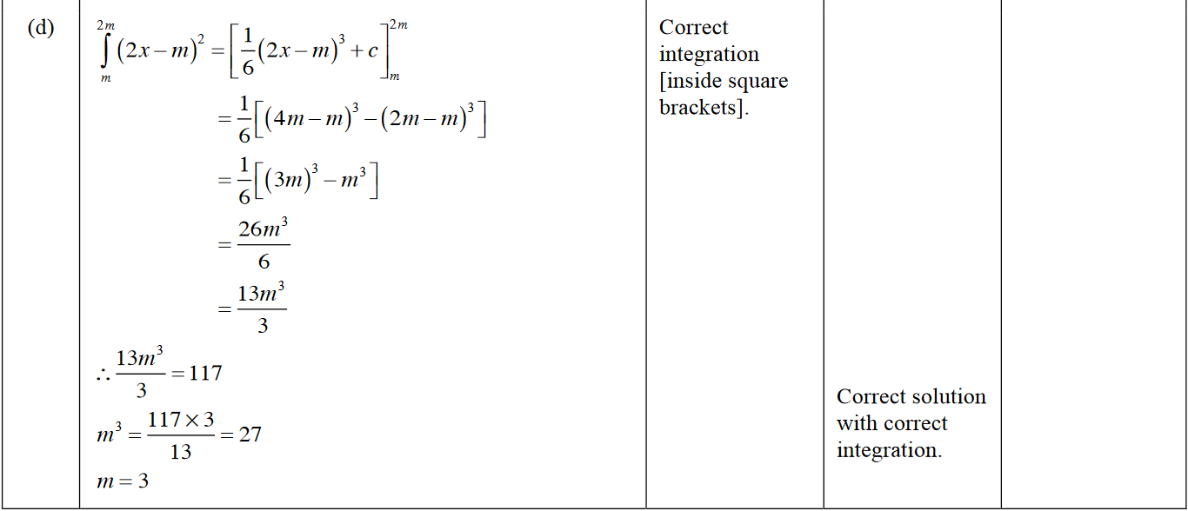

2016 Question 3a.
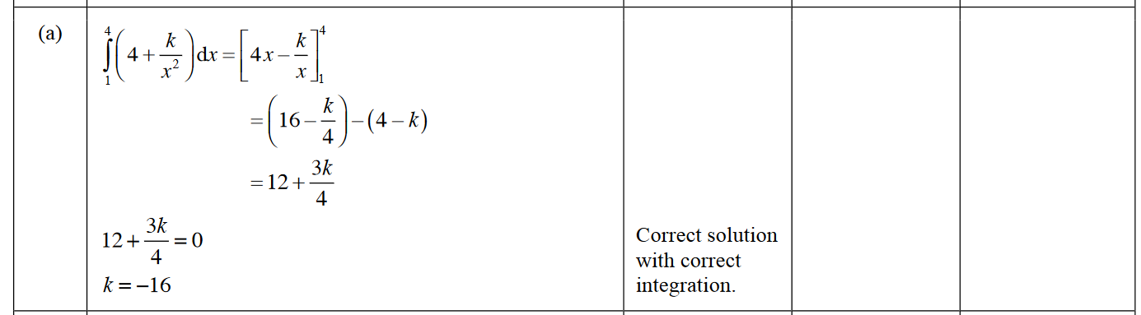

2016 Question 3d.
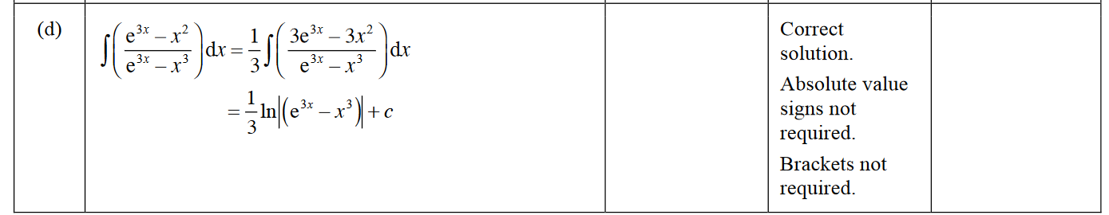

2015 Question 1a.

2015 Question 2a.
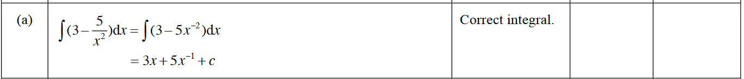

2015 Question 3a.

2014 Question 1a.

2014 Question 2a.

2014 Question 3b.

2014 Question 3d.
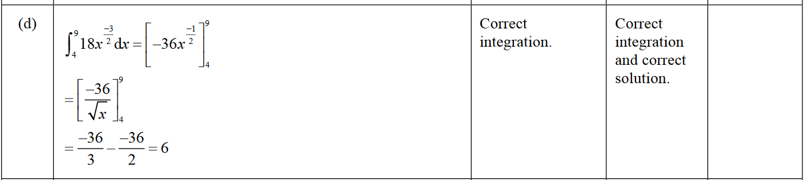

2013 Question 1a.

2013 Question 1b.

2013 Question 2b.
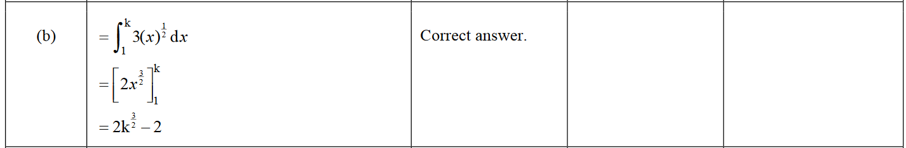

2013 Question 3a.

2013 Question 3c.
