Algebra Collated Past Papers - Algebraic Manipulation

2023 Question 3a.
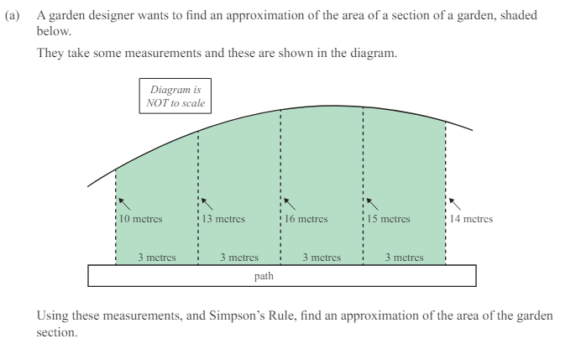

2022 Question 3b.
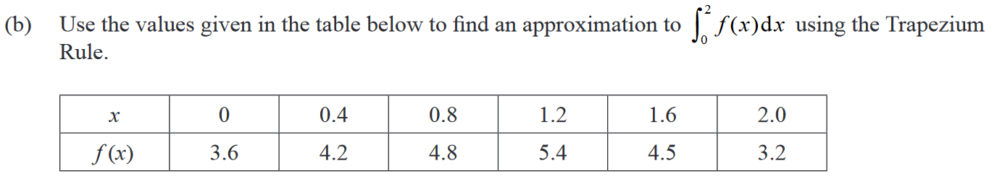

2021 Question 3b.
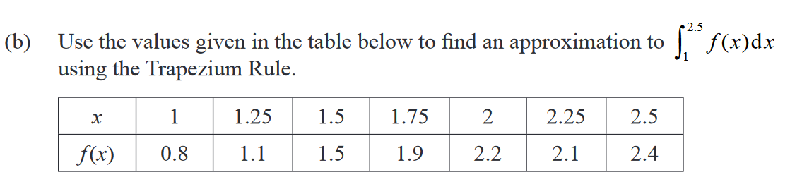

2020 Question 2b.
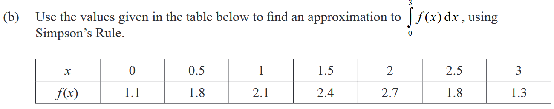

2019 Question 1b.
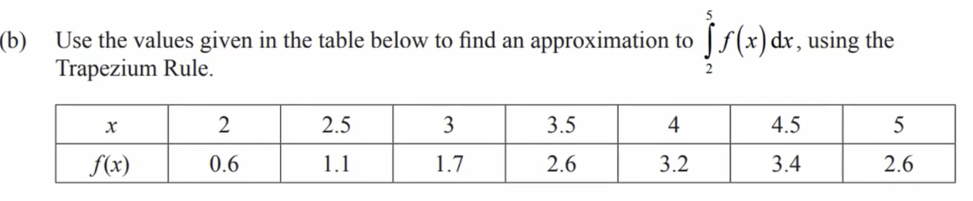

2018 Question 3b.
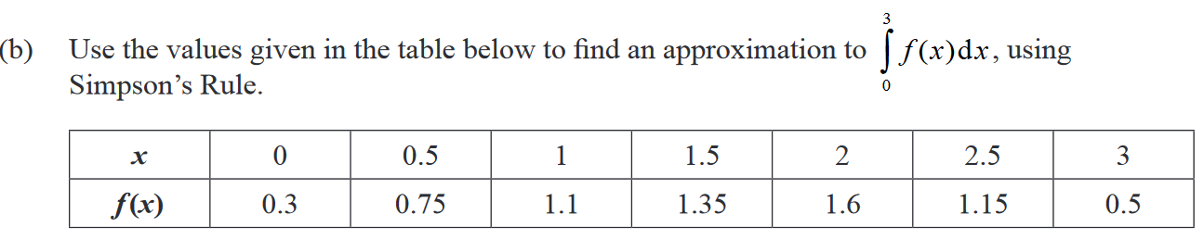

2017 Question 3b.
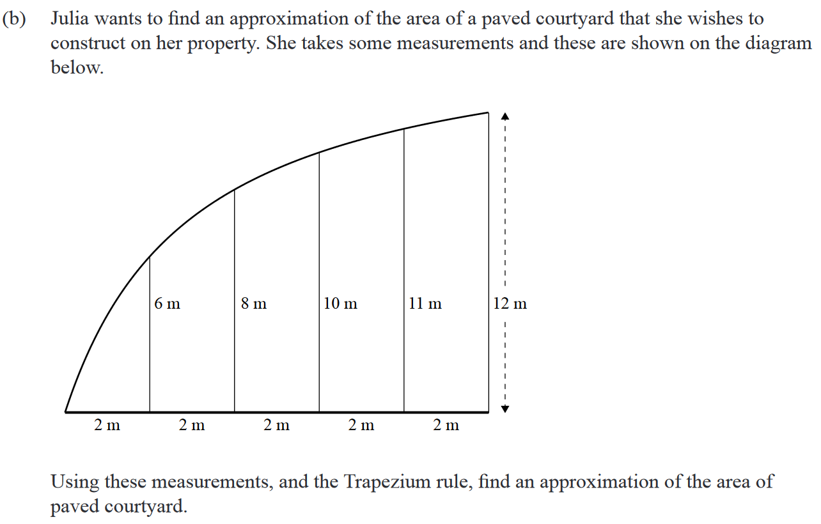

2016 Question 3b.
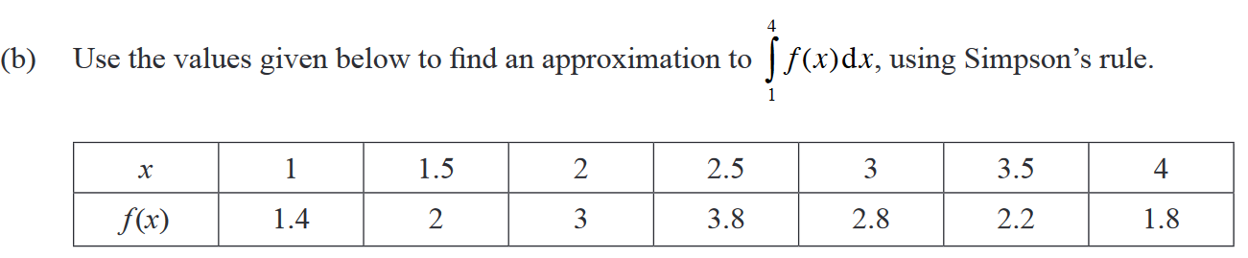

2015 Question 2b.
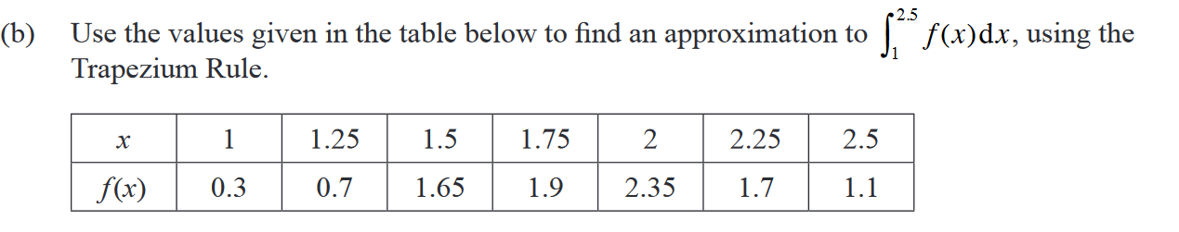

2014 Question 3a.
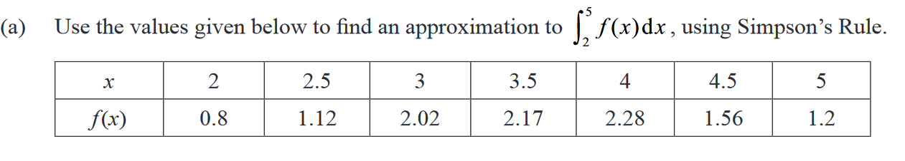

2013 Question 2a.
