Algebra Collated Past Papers - Algebraic Manipulation

2023 Question 1d.
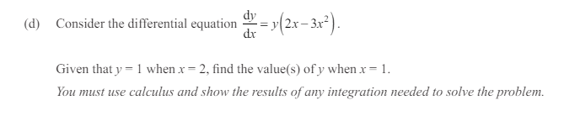

2023 Question 2b.
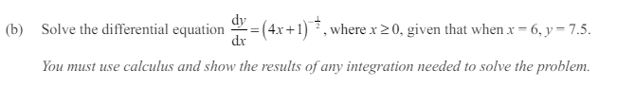

2023 Question 2e.
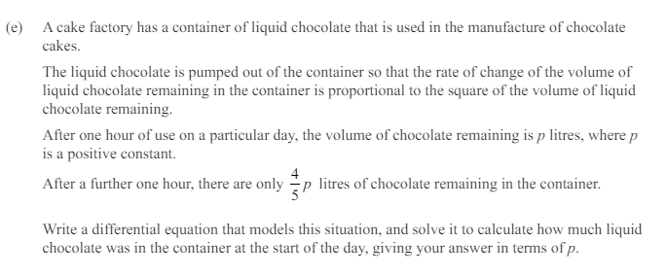

2023 Question 3e.
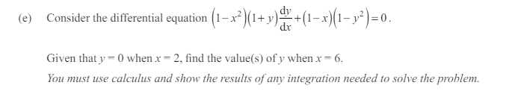

2022 Question 1b.
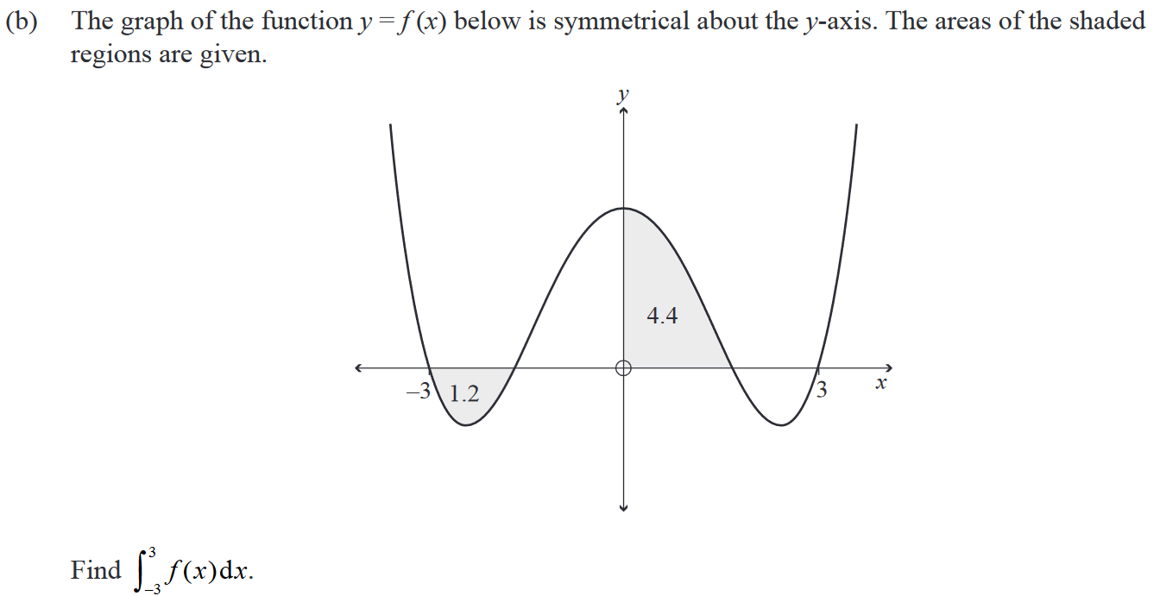

2022 Question 1d.
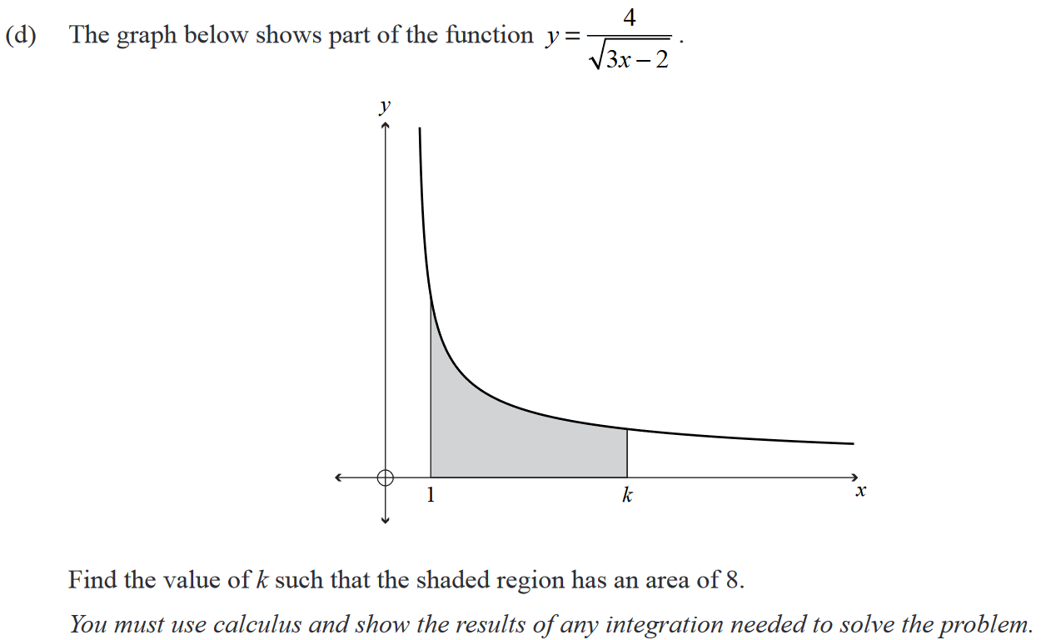

2022 Question 1e.
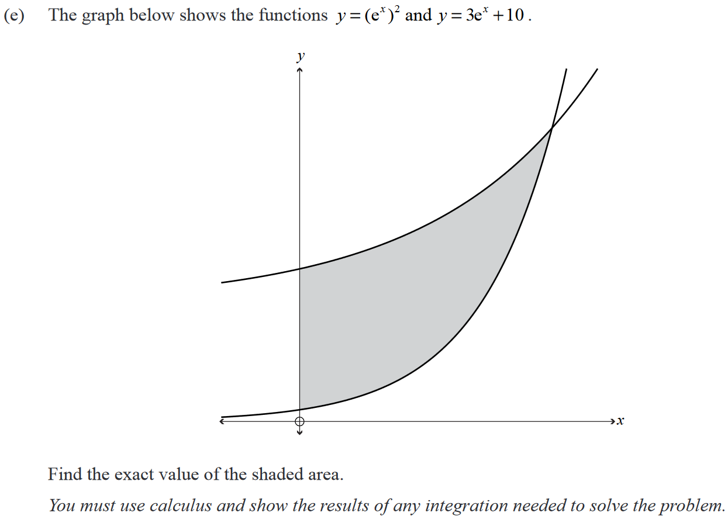

2022 Question 2c.
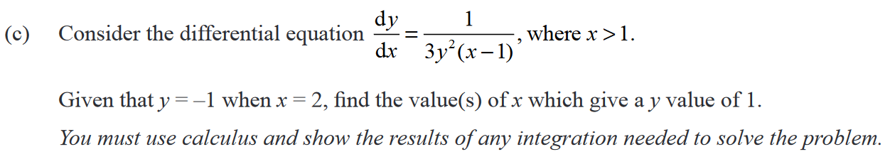

2022 Question 2e.
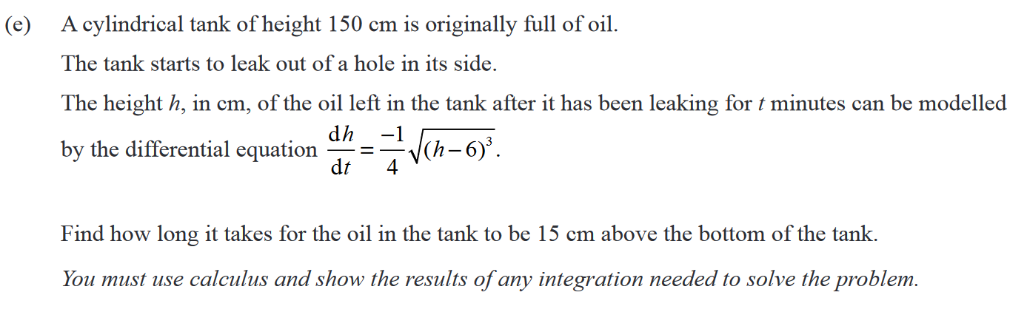

2021 Question 1b.
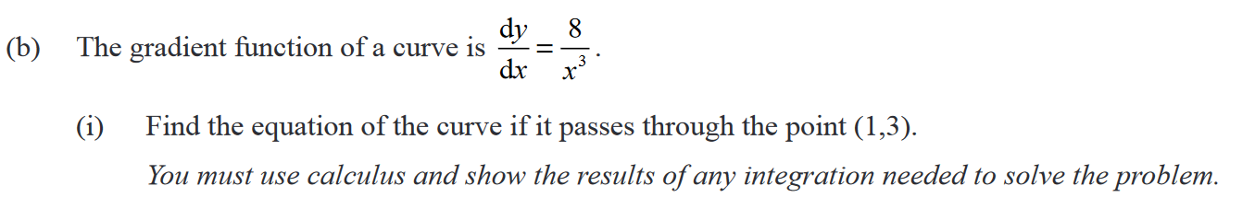

2021 Question 1c.
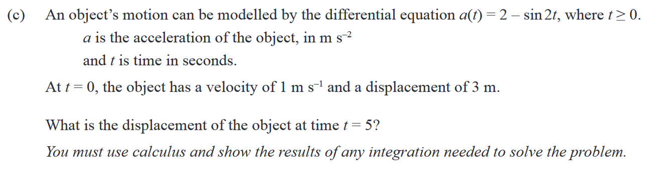

2021 Question 2e.
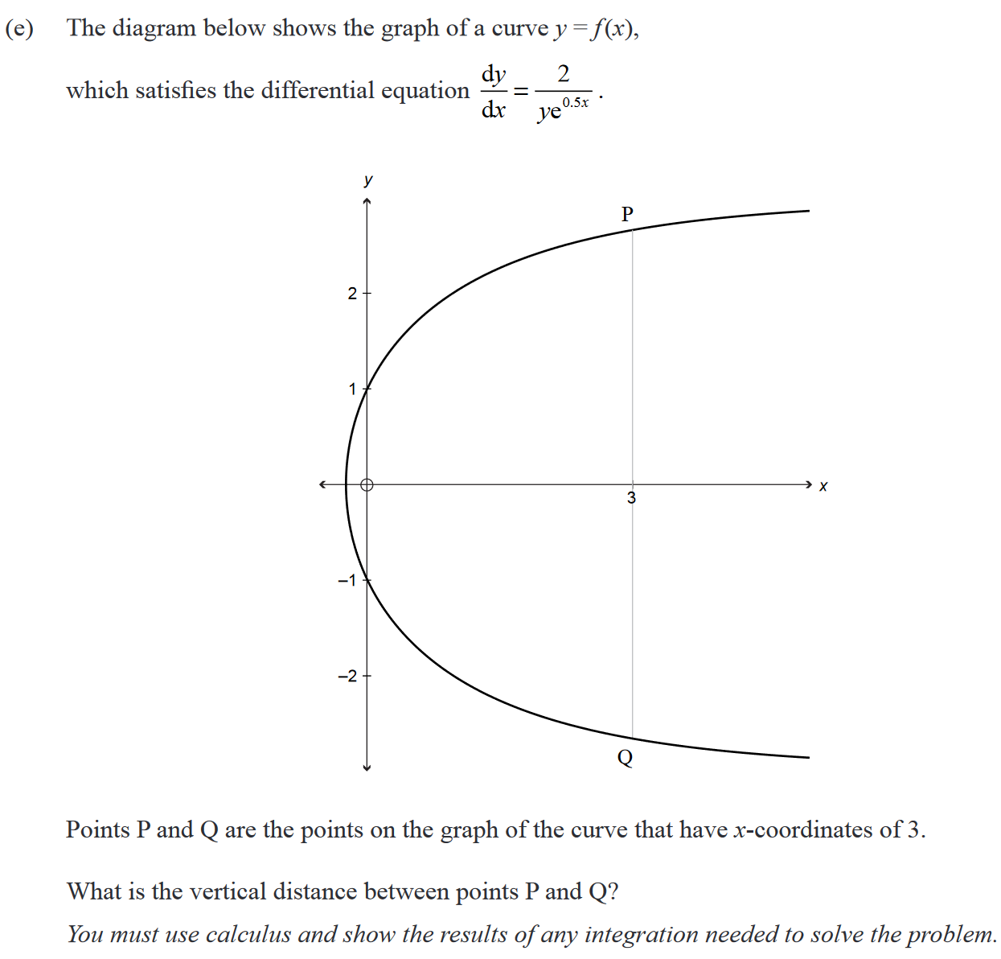

2021 Question 3c.
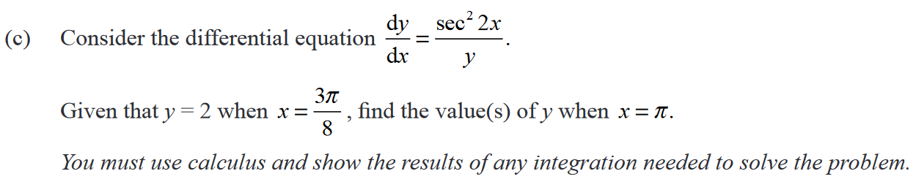

2020 Question 1e.
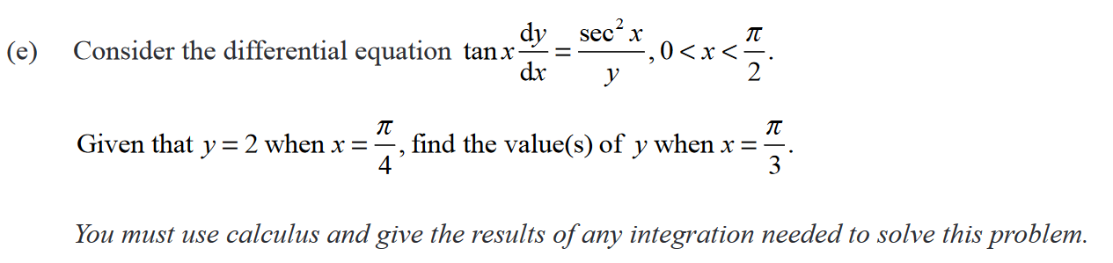

2020 Question 2d.
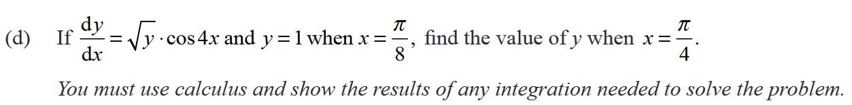

2020 Question 3b.
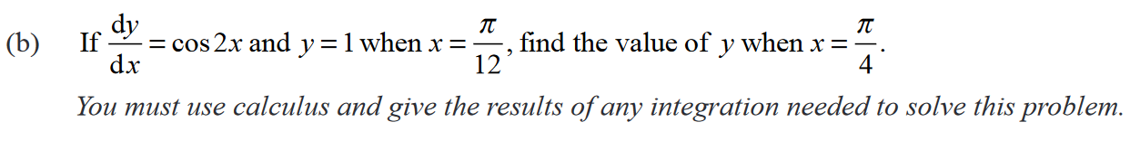

2019 Question 1e.
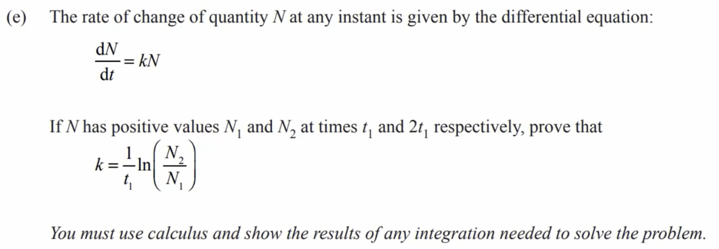

2019 Question 3b.

2019 Question 3d.
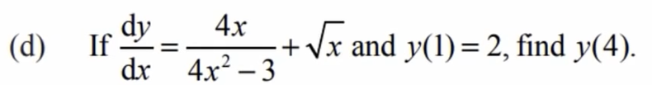

2018 Question 1b.

2018 Question 1d.
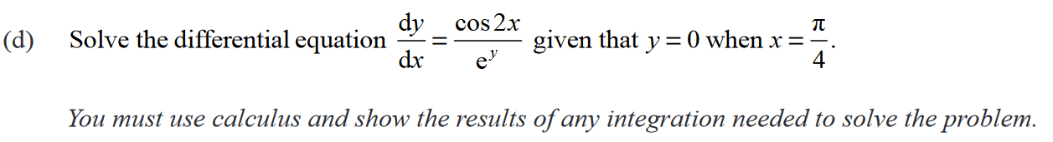

2017 Question 3d.
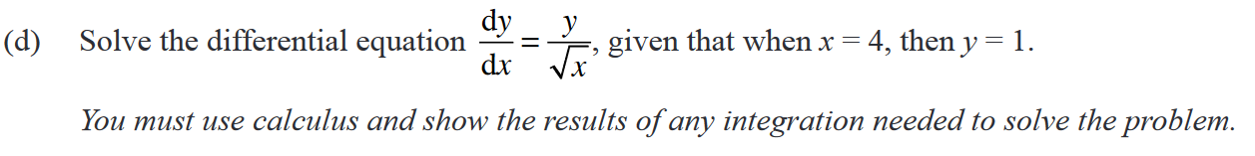

2017 Question 3e.
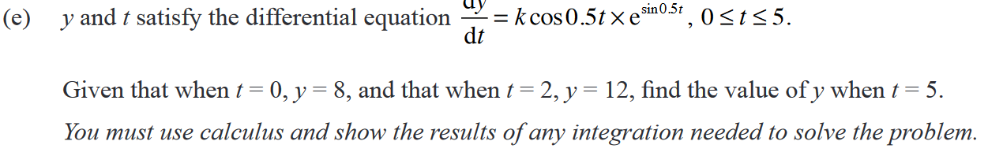

2016 Question 1c.
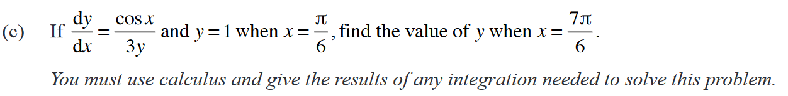

2016 Question 3e.
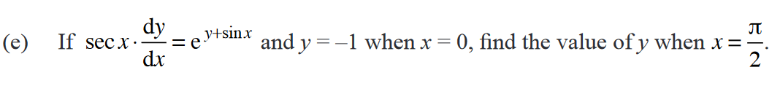

2015 Question 1b.
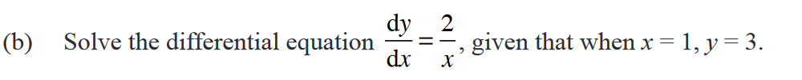

2015 Question 1c.
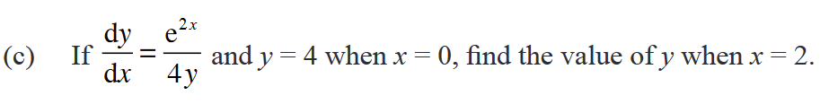

2015 Question 2d.
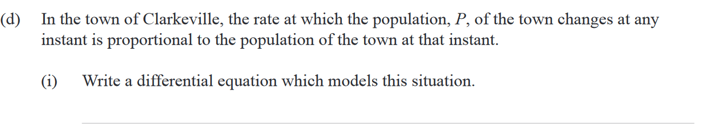

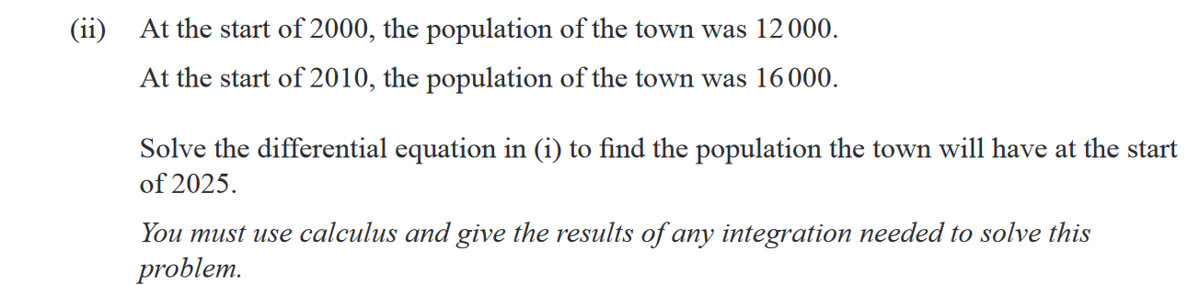

2014 Question 2b.

2014 Question 2d.
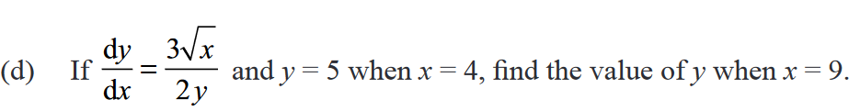

2014 Question 3c.
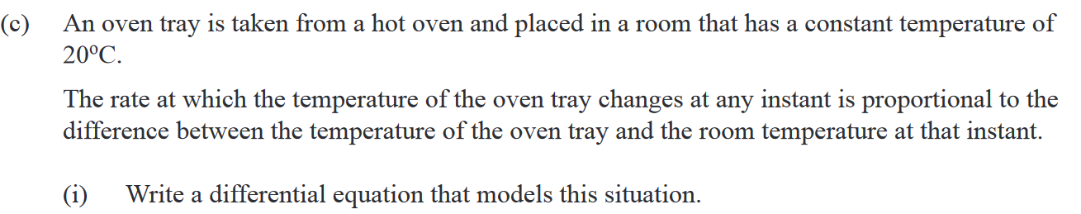

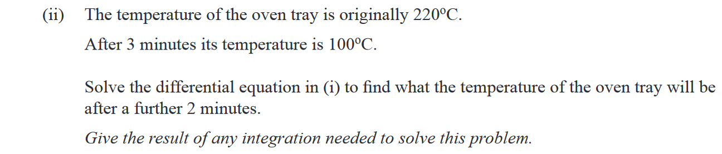

2013 Question 1d.
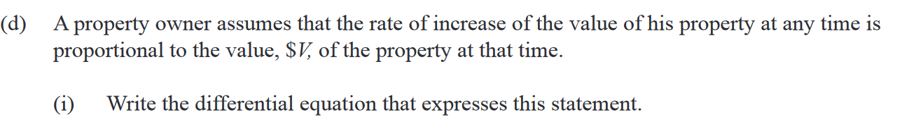

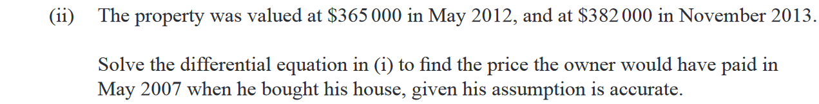

2013 Question 3e.
