Probability Collated Past Papers – Normal Distributions

2023 Question 3a.
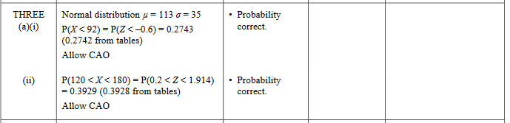

2022 Question 1a.
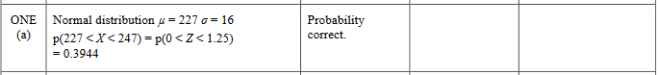

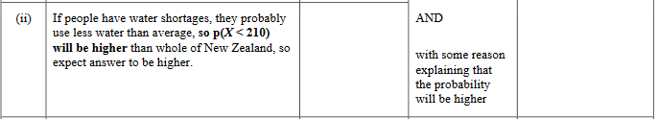

2021 Question 3a.
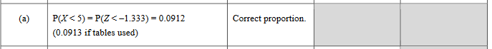

2021 Question 3b.
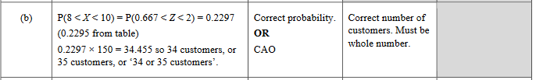

2020 Question 2a.

2019 Question 2a.
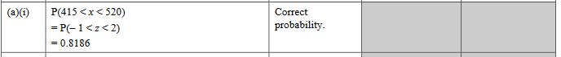

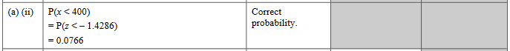

2019 Question 2d.
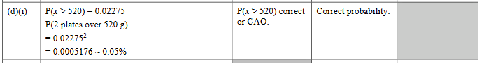

2018 Question 1a.
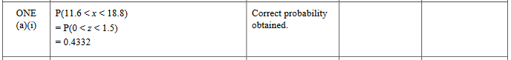

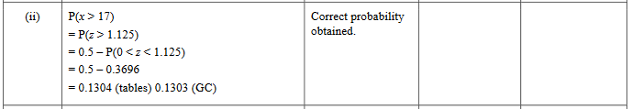

2018 Question 1b.
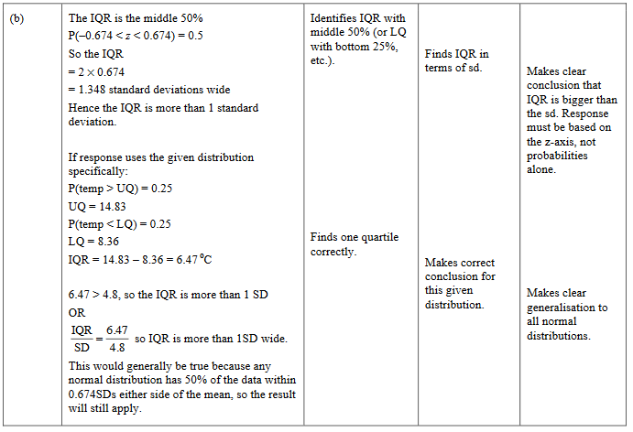

2017 Question 3a.

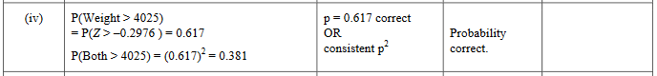

2016 Question 3a.

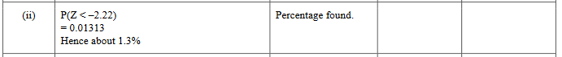

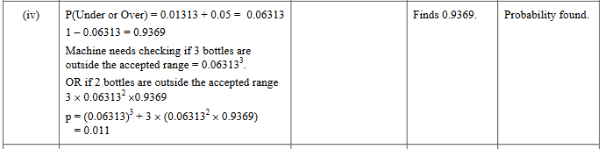

2015 Question 1a.

2015 Question 1b.

2014 Question 2a.

2012 Question 1a.

2012 Question 1d.
