Probability Collated Past Papers – Inverse Normal

2023 Question 3b.
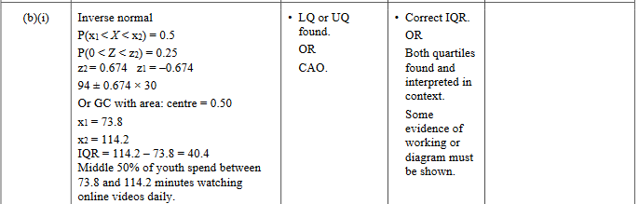

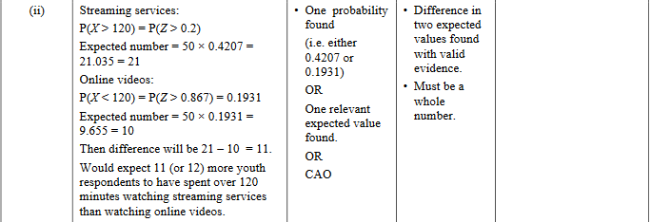

2022 Question 1d.
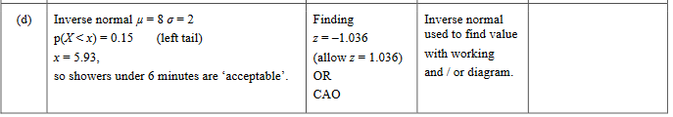

2021 Question 3d.
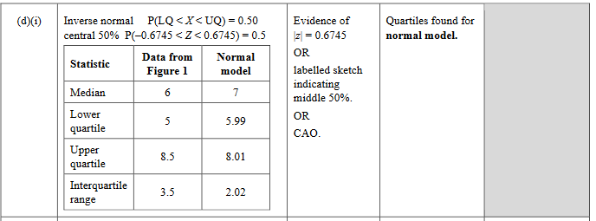

2020 Question 2a.
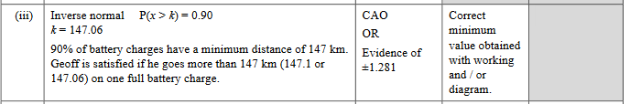

2020 Question 2b.
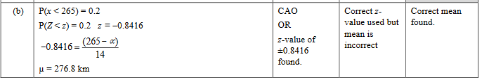

2019 Question 2b.
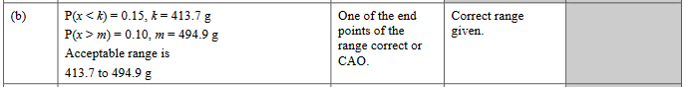

2019 Question 2c.
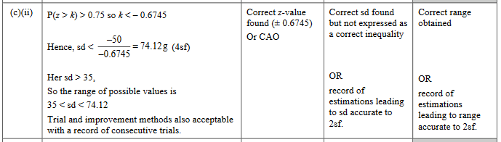

2018 Question 1a.
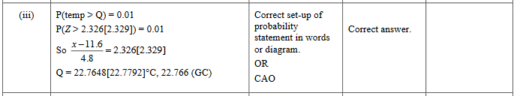

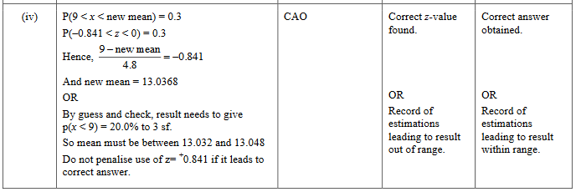

2017 Question 3b.
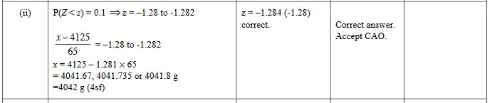

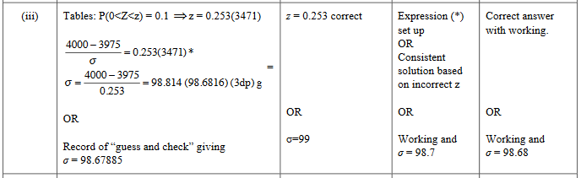

2016 Question 3a.
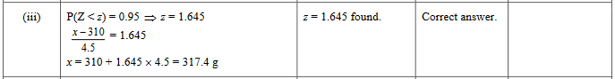

2015 Question 1a.
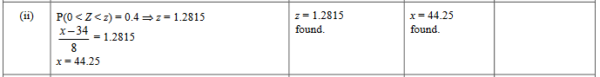

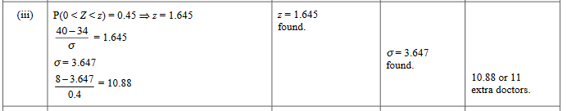

2014 Question 2b.
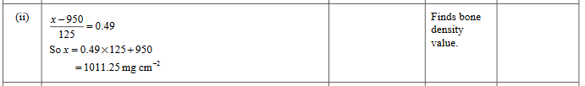

2014 Question 2b.
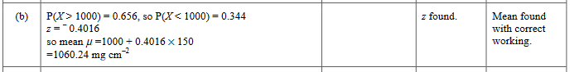

2012 Question 1c.

2012 Question 1e.
