Calculus Collated Past Papers – Differentiation

2023 Question 1a-c.
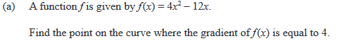

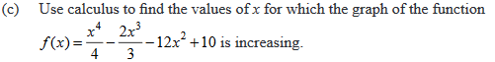

2023 Question 3a.

2022 Question 1a-c.
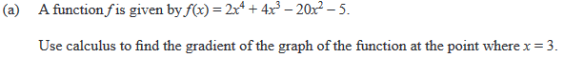

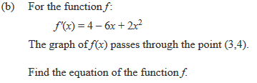

2022 Question 2c.
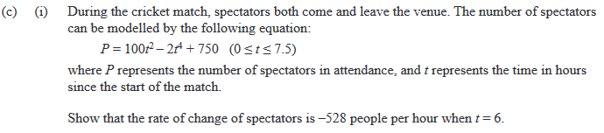

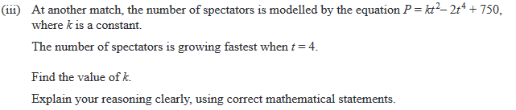

2021 Question 1a.
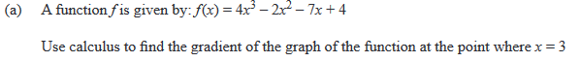

2021 Question 2b.
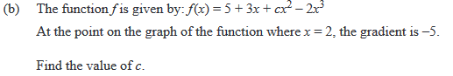

2021 Question 3a.
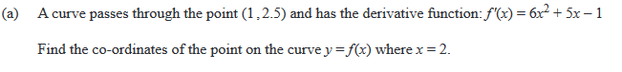
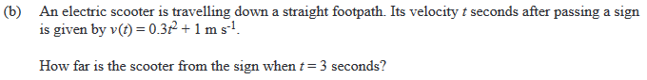

2020 Question 1a.
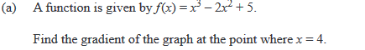

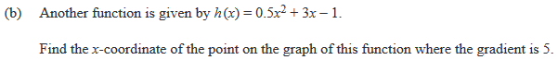

2020 Question 1d.
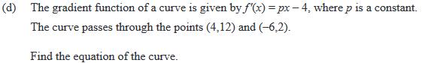

2020 Question 3a.
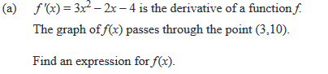

2020 Question 3d.
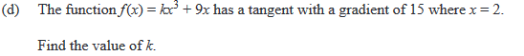

2019 Question 1a.
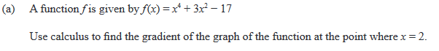

2019 Question 2b.
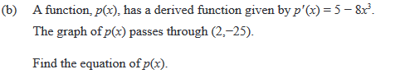

2018 Question 1a.
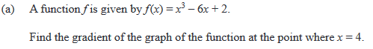

2018 Question 3a.
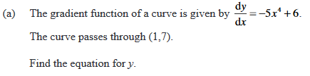

2017 Question 1a.
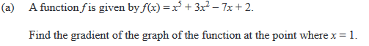

2017 Question 3a.
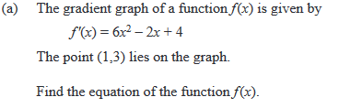

2016 Question 1a.
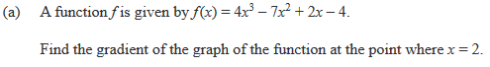

2016 Question 2c.
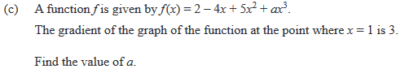

2016 Question 3a.
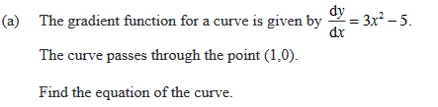

2015 Question 1a.
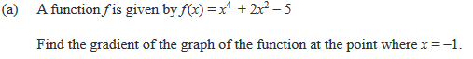

2015 Question 2a.
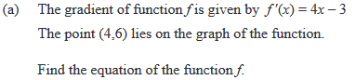

2014 Question 1a.
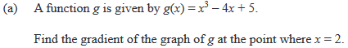

2014 Question 1b.
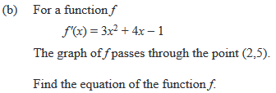

2014 Question 1d.
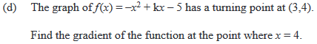

2014 Question 2b.
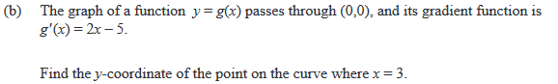

2014 Question 3a.

2013 Question 1a.
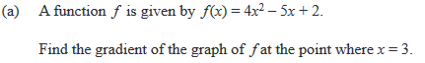

2013 Question 1b.
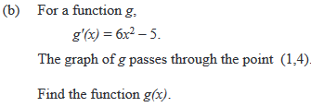

2013 Question 1f.
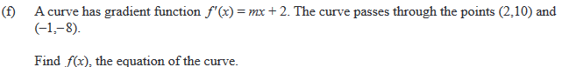

2013 Question 3a.
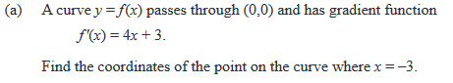

2012 Question 1a.
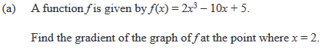

2012 Question 1b.
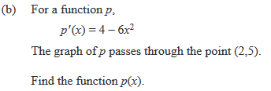

2012 Question 2b.

MOVE THIS

2012 Question 3a.
