Calculus Collated Past Papers – Optimisation

2023 Question 1d.
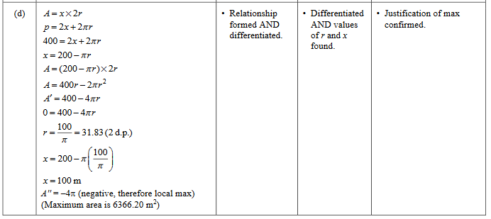

2023 Question 2c.
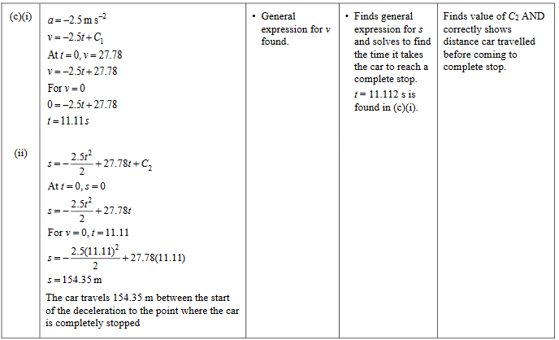

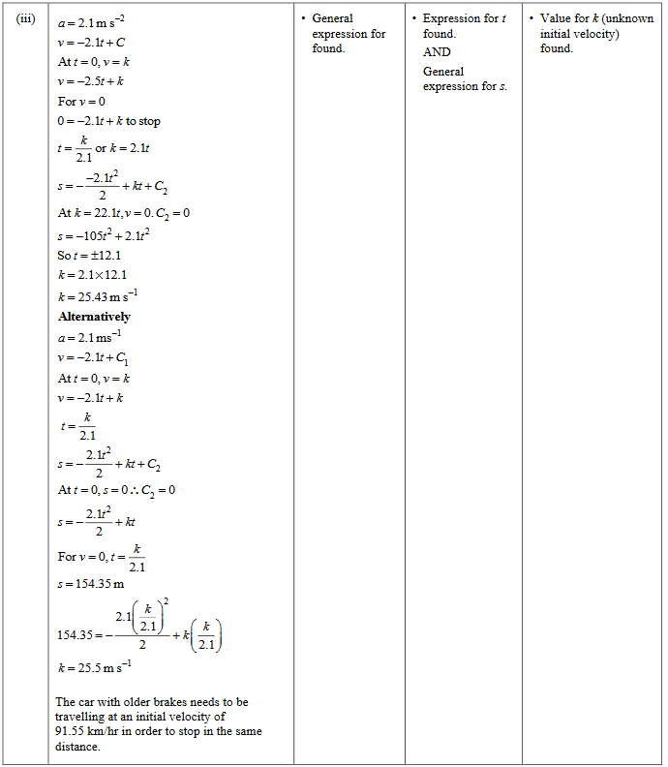

2023 Question 3b.
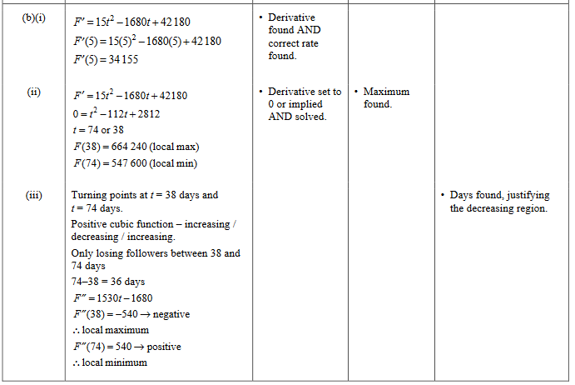

2022 Question 1e.
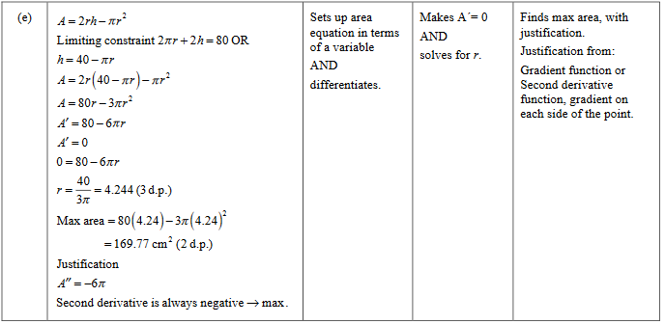

2022 Question 3c.
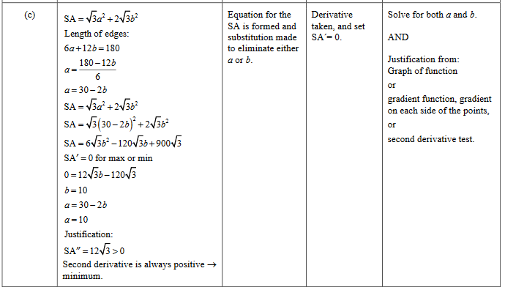

2021 Question 1c.
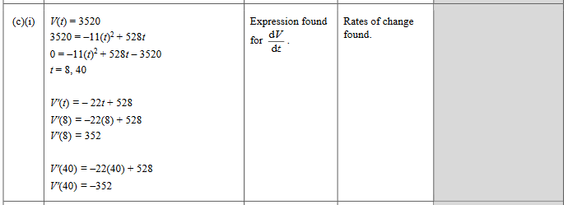

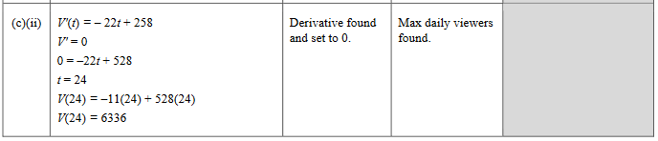

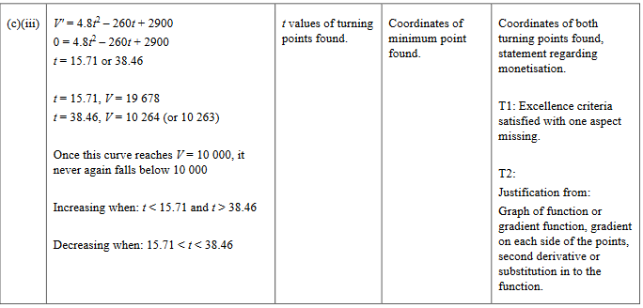

2021 Question 2c.
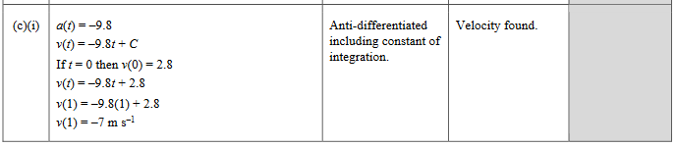

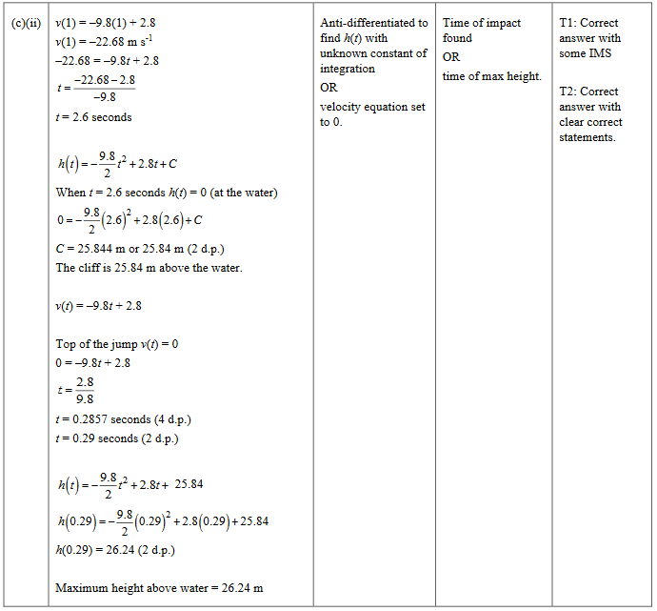

2021 Question 3d.
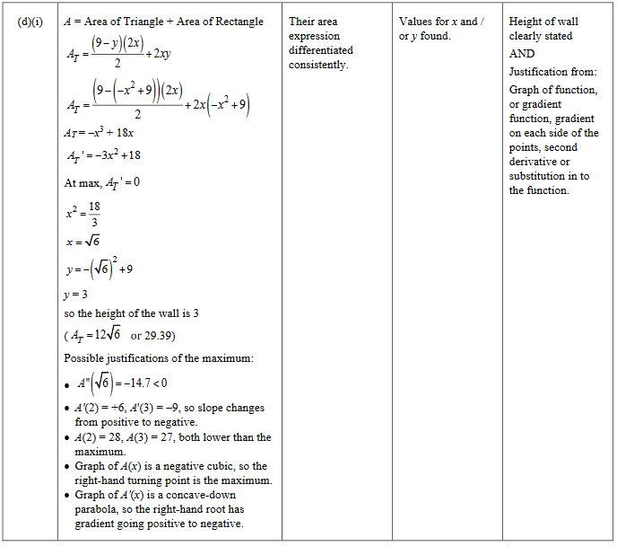

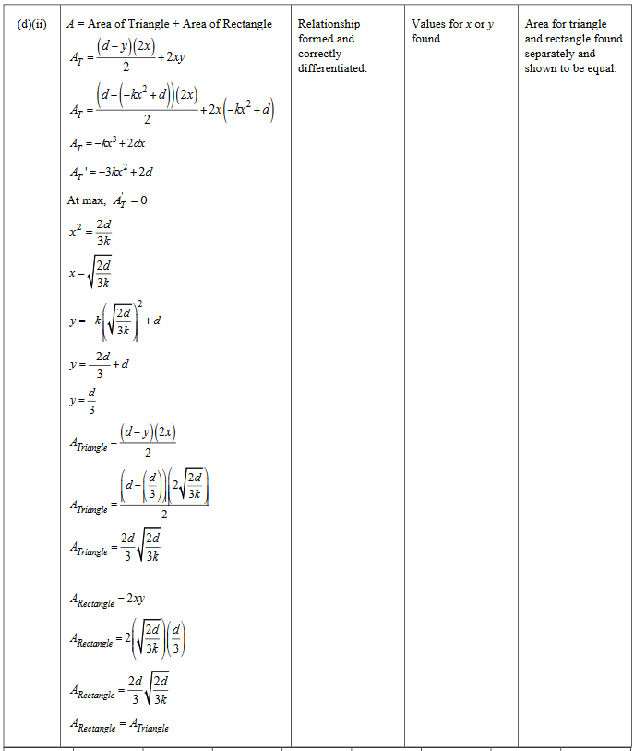

2020 Question 2b.
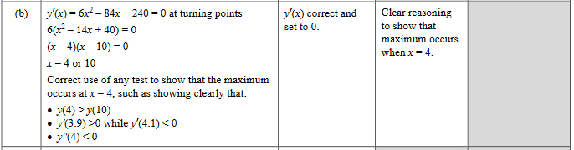

2020 Question 2e.
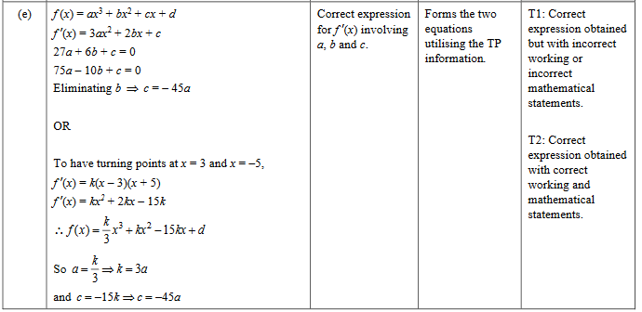

2020 Question 3e.
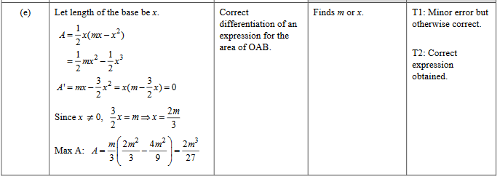

2019 Question 3b.
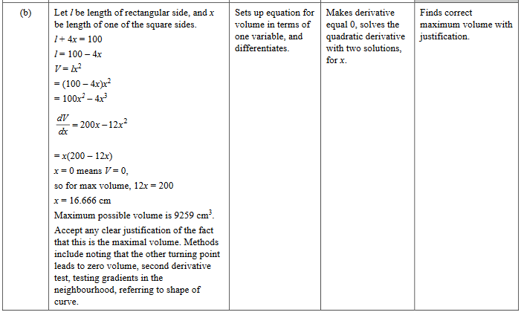

2018 Question 1c.
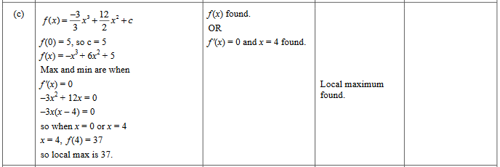

2018 Question 1e.
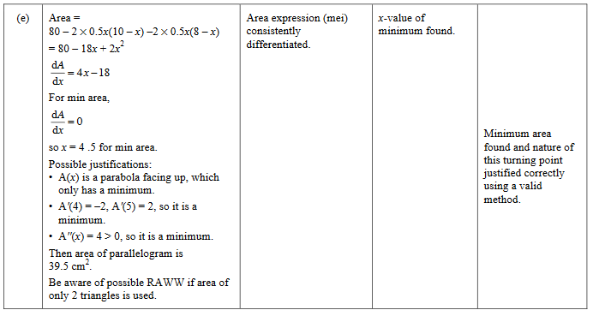

2018 Question 2b.
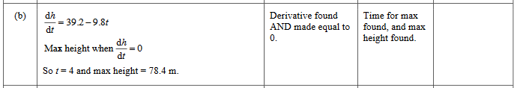

2018 Question 2e.
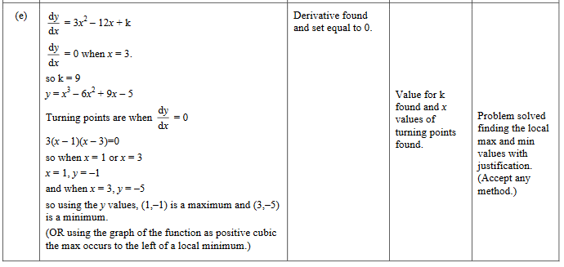

2018 Question 3c.
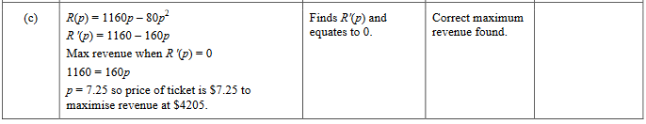

2017 Question 1e.
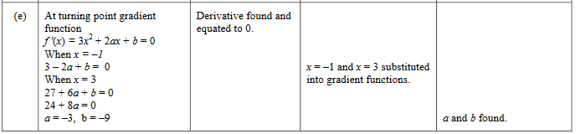

2017 Question 2e.
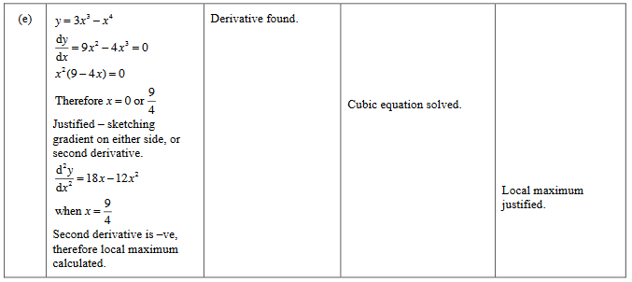

2017 Question 3d.
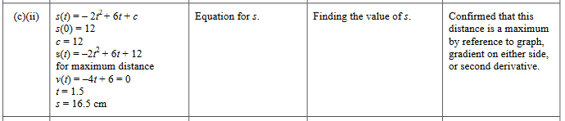

2016 Question 1c.
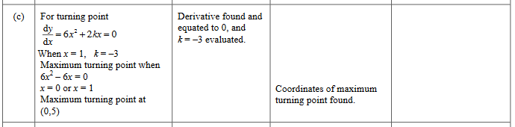

2016 Question 1e.
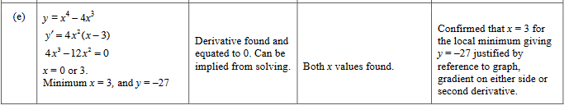

2015 Question 2c.
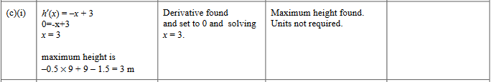

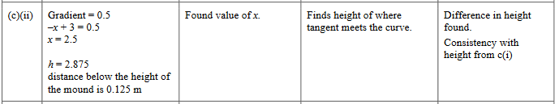

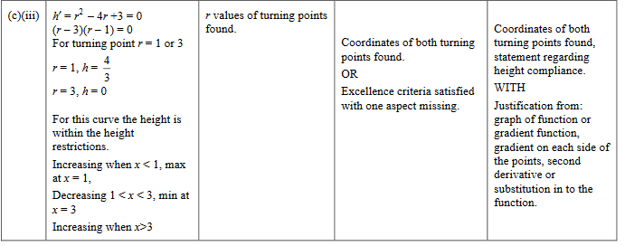

2015 Question 3c.
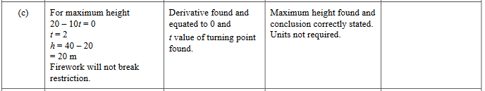

2015 Question 3e.
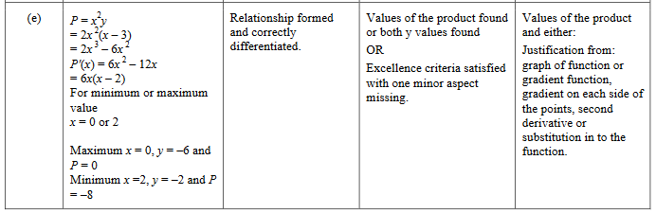

2014 Question 1c.
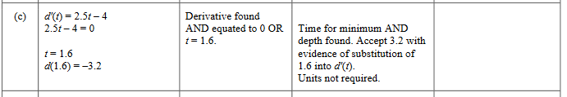

2014 Question 2e.
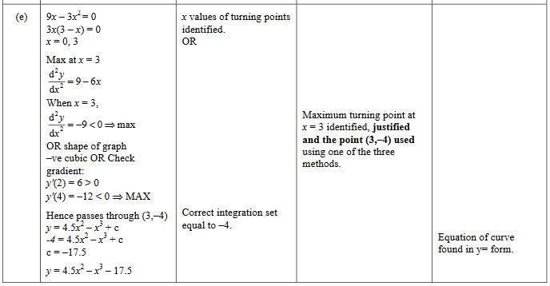

2014 Question 3d.
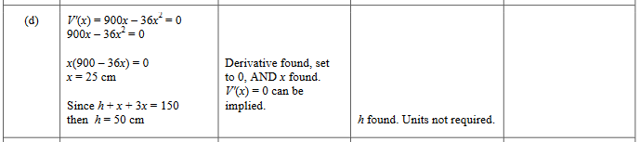

2013 Question 1c.
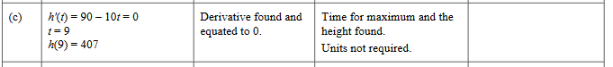

2013 Question 2e.
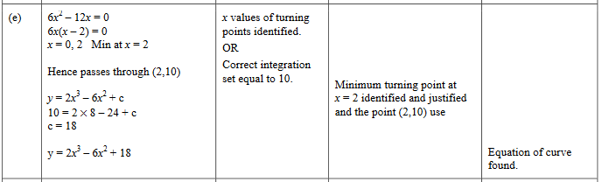

2013 Question 3e.
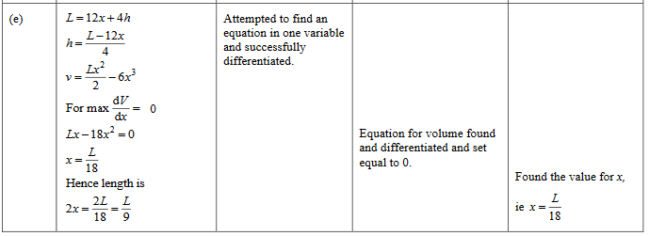

2012 Question 1d.
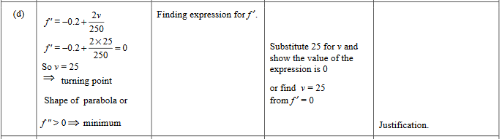

2012 Question 2d.
