Calculus Collated Past Papers – Rates of Change

2020 Question 3b.
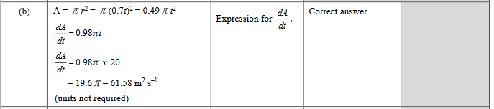

2019 Question 1c.
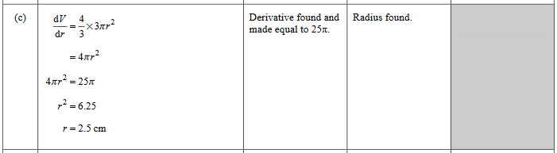

2018 Question 1b.
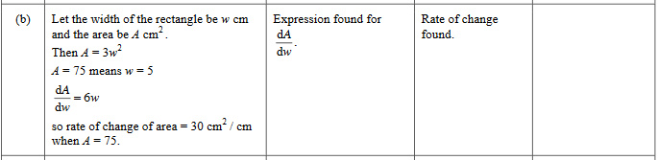

2018 Question 3b.
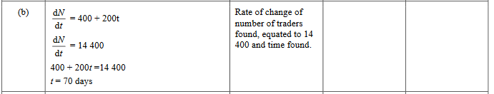

2016 Question 2d.
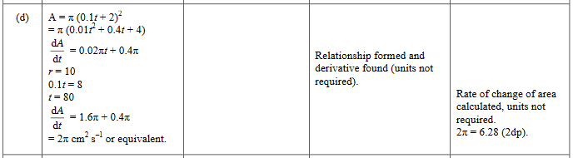

2015 Question 1c.
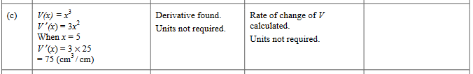

2014 Question 2c.
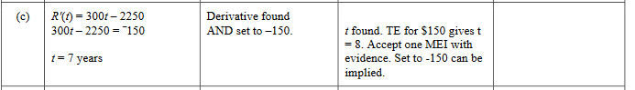

2014 Question 3b.
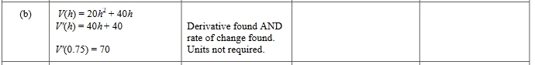

2014 Question 3c.
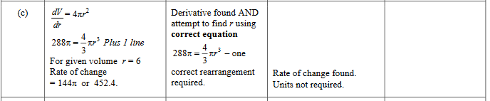

2014 Question 3f
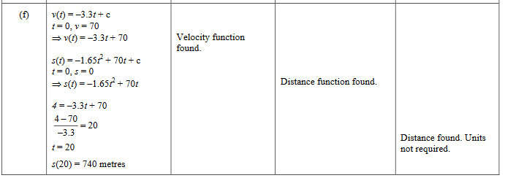

2013 Question 1d.
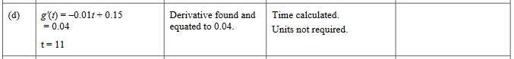

2013 Question 2b.
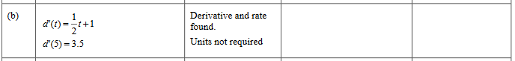

2013 Question 2c.
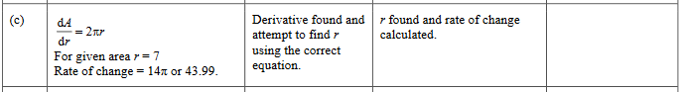

2012 Question 1c.
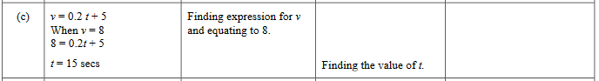

2012 Question 3b.
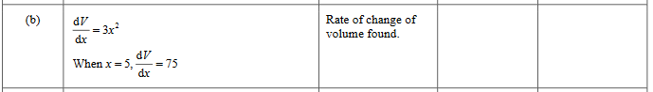

2012 Question 3e.
